上海电力大学

《高级语言程序设计》
课程设计



题目： 学校档案管理系统
院系： 计算机科学与技术学院
专业年级： 计算机科学与技术2018级
学生姓名： 洪勇 学号： 20181389
指导教师： 叶文君
成绩:

2019年5月

目录
目录 1
1． 需求分析 2
2． 概要设计 3
3． 详细设计 6
4． 用户使用手册 26
4.1 环境设置 26
4.2 操作步骤 27
5． 程序创新点 32
6． 使用的主要技术 33
7． 总结 34
附录 35

需求分析
学校是一个群体，每个人都有自己的属性档案。每个学校都需要有一个档案管理系统去管理本校的职员和学生信息。
学校一般会有一般人员，学生，教师和研究生。人员的资料有姓名，性别，年龄。学生的资料有姓名，性别，年龄，派系，学号。教师的资料有姓名，性别，年龄，职称，任教课程。研究生的资料有姓名，性别，年龄，派系，学号，导师。所有人的资料都会发生变动，例如年龄变更，学号变更，派系变更等等。而学校的人员也会发生变动，可能需要增添和删除资料。
有时我们需要查找某个某个学校成员的资料，可能是为了查看，修改，或者是增删。我们为了以后方便读取和调用，需要把信息读写进txt文件。经过输入，查找，增删等操作后，我们也需要及时地进行保存进txt。当用户急需查找某个资料时，也可以打开txt直接查找。
人员类包括信息：
姓名，年龄，性别。
学生类包括信息：
姓名，年龄，性别，派系，学号。
教师类包括信息：
姓名，年龄，性别，担任课程，职称。
研究生包括信息：
姓名，年龄，性别，派系，学号，导师。
系统主体功能：
- 读写数据。
- 显示所有数据。
- 增加档案信息。
- 删除档案信息。
- 更改档案信息。
- 查找档案信息
- 保存档案信息
- 将档案信息写进txt文件
- 退出程序

概要设计
Basedata类：用于存放姓名，性别，年龄。
class base_massage {
public:
string name;//用于存放姓名
bool sex;//用于存放性别
int age;//用于存放年龄
};
人员类：有3个数据，用于存放具体信息。
class person {
private:
base_massage b_m;//用于存放基本信息
public:
//以下bool类数据都是为搜查做为依据数据
bool inspection_name;
bool inspection_sex;
bool inspection_age;
bool inspection_number;
bool inspection_department;
bool inspection_perfessor;
bool inspection_course;
bool inspection_tutor;
bool inspection_name_1;
bool inspection_sex_1;
bool inspection_age_1;
bool inspection_number_1;
bool inspection_department_1;
bool inspection_perfessor_1;
bool inspection_course_1;
bool inspection_tutor_1;

public:
person();//构造函数，初始化所有值
virtual int input() ;//输入函数，用于输入数据
virtual void output();//输出函数，用于将数据输出
virtual void alter();//转换函数，用于改变数据
virtual string getname();//获取姓名函数
virtual bool getsex();//获取性别函数
virtual int getage();//获取年龄函数
virtual string set_name(string a);//输入姓名函数
virtual bool set_sex(bool a);//输入性别函数
virtual int set_age(int a);//输入年龄函数
virtual string set_number(string a);//输入学号函数
virtual string set_department(string a);//输入派系函数
virtual string set_perfessor(string a);//输入职称函数
virtual string set_course(string a);//输入担任课程函数
virtual string set_tutor(string a);//输入导师函数
virtual string getnumber();//获取学号函数
virtual string getdepartment();//获取派系函数
virtual string getperfessor();//获取职称函数
virtual string getcourse();//获取担任课程函数
virtual string gettutor();//获取导师函数
virtual void file_input();//写入文件函数
};
学生类，教师类，研究生类函数与上面基本相同。
学生类：
class student :public person {
private:
base_massage b_m;
string number;
string department; //用于存放基本信息
}
教师类：
class teacher :public person {
private:
base_massage b_m;
string perfessor;
string course;} //用于存放基本信息
研究生类：
class graduatestudent :public student {
private:
base_massage b_m;
string number;
string department;
string tutor; //用于存放基本信息
}
成员函数：
void menu_welcome(person* per[],int* count);//欢迎界面函数
void menu_read(person* per[], int* count);//录入数据界面函数
void menu_main(person* per[], int* count);//主体功能函数
void menu_alter(person* per[], int* count);//更改数据功能界面函数
void menu_save(person* per[], int* count);//保存数据界面函数
void menu_exit(person* per[], int* count);//退出程序函数

void inspection_age(person*per[], int* count, int age, int a);//搜查年龄函数
void inspection_name(person*per[], int* count, string name, int a);//搜查姓名函数
void inspection_number(person*per[], int* count, string number, int a);//搜查学号函数
void inspection_department(person*per[], int* count, string department, int a);//搜查系派函数
void inspection_perfessor(person*per[], int* count, string perfessor, int a);//搜查职称函数
void inspection_course(person*per[], int* count, string course, int a);//搜查课程函数
void inspection_tutor(person*per[], int* count, string tutor, int a);//搜查导师函数
void inspection_sex(person*per[], int* count, bool sex, int a);//搜查性别函数
void inspection(person*per[], int* count, int a);//搜查函数
void inspection_zero(person*per[], int a);//搜查条件关闭函数
void inspection_close(person*per[], int a);//搜查权限关闭函数
void inspection_open(person*per[], int a);//查阅权限启动函数

void alter_information(person* per[], int* count);//更改信息函数
void delete_information(person* per[],int* count);//删除信息函数

void file_input(person* per[], int count);//文件写入函数
void file_read(person* per[], int* count1);//文件读取函数

int statics_input(person* per[], int* count);//数据输入函数
void statics_output(person* per[], int* count);//数据输出函数
int static_add(person* per[], int* count);//数据增添函数
void statics_output_1(person* per[], int* count);//单项数据输出函数

详细设计
/*人员类成员函数实现*/
int person::input() {system("cls");cout << "请输入姓名：";cin >> b_m.name;
cout << "请输入性别：（1）男（0）女" << endl;cout << "请输入序号:";
int i = 0;cin >> i;while (i!=1&&i!=0){
cout << " 您输入有误！请重新输入！ " << endl;
cout << "=================================================================" << endl;
cout << endl << endl << endl;
cout << "请输入序号:";
cin >> i;}
if (i == 1)
b_m.sex = true;
else
b_m.sex = false;cout << "请输入年龄：";cin >> b_m.age;return 0;}
void person::output() {cout << setw(20) << left<< "类型" << setw(20) << "姓名" << setw(20) <<
"性别" << setw(20) << "年龄" << setw(20) << endl;
cout << endl;
cout << setw(20) << left << "人员";
cout << setw(20) << left << b_m.name;
if (b_m.sex)
cout << setw(20) << left<<"男";
else
cout << setw(20) << left<<"女";
cout << setw(20) << left << b_m.age << endl << endl << endl;}
void person::alter() {
int temp;
cout << "请选择修改的方式" << endl;
cout << "(1)全部修改（2）部分修改" << endl;
cout << "请输入序号：";
cin >> temp;
int flag = 1;
while (flag == 1){
if (temp == 1)
input();
else if (temp == 2) {
int choice;cout << "您希望改哪个部分？" << endl;
cout << "(1)姓名（2）性别（3）年龄" << endl;cout << "请输入序号：";
cin >> choice;
if (choice == 1) {cout << "请输入姓名：";cin >> b_m.name;}
else if (choice == 2) {cout << "请输入性别：（1）男（0）女" << endl;
cout << "请输入序号:";cin >> b_m.sex;}
else if (choice == 3) {cout << "请输入年龄：";cin >> b_m.age;}
else {cout << "您输入有误！";continue;}}
else {cout << "您输入有误！";continue;}cout << "您希望继续修改吗？";
cout << "(1)是(0)否" << endl;cout << "请输入序号:";cin >> flag;}
cout << "修改完成！" << endl;}
string person::set_name(string a) {b_m.name = a;return b_m.name;};//
bool person::set_sex(bool a) {b_m.sex = a;return b_m.sex;};//
int person::set_age(int a) {b_m.age = a;return b_m.age;};//
string person::set_number(string a) {return "";};//
string person::set_department(string a) {return "";};//
string person::set_perfessor(string a) {return "";};//
string person::set_course(string a) {return "";};//
string person::set_tutor(string a) {return "";};//
string person::getname() {return b_m.name;}//
bool person::getsex() {return b_m.sex;}//
int person::getage() {return b_m.age;}//
string person::getnumber() {return " ";}//
string person::getdepartment() {return " ";}//
string person::getperfessor() {return " ";}//
string person::getcourse() {return " ";}//
string person::gettutor() {return " ";}//
void person::file_input() {ofstream open("storage.txt", ios::app);
if (!open)
cout << "打开失败！" << endl;
open << "人员" << "\t";open << b_m.name << "\t";open << b_m.age << "\t";
if(b_m.sex==1)
open << "男" << endl;
else
open << "女" << endl;
open.close();} //
person::person() {inspection_age = true;inspection_course = true;
inspection_department = true;inspection_name = true;inspection_number = true;
inspection_perfessor = true;inspection_sex = true;inspection_tutor_1 = true;
inspection_age_1 = true;inspection_course_1 = true;inspection_department_1 = true;
inspection_name_1 = true;inspection_number_1 = true;inspection_perfessor_1 = true;
inspection_sex_1 = true;inspection_tutor = true;};
/*学生类成员函数的实现*/
int student::input() {system("cls");cout << "请输入学号：";cin >> number;
cout << "请输入姓名：";cin >> b_m.name;
cout << "请输入性别：（1）男（0）女" << endl;cout << "请输入序号:";int i = 0;
cin >> i;while (i != 1 && i != 0){
cout << " 您输入有误！请重新输入！ " << endl;
cout << "=================================================================" << endl;
cout << endl << endl << endl;cout << "请输入序号:";cin >> i;}
if (i == 1)
b_m.sex = true;
else
b_m.sex = false;
cout << "请输入年龄：";cin >> b_m.age;cout << "请输入系别：";cin >> department;
return 0;};
void student::output() {
cout << left << setw(20) << "类型" << setw(20) << "姓名" << setw(20) <<"性别" << setw(20) << "年龄" << setw(20) << "学号" << setw(20) <<"系别" << endl;
cout << endl;cout << setw(20) << left << "学生";cout << setw(20) << left << b_m.name;
if (b_m.sex)
cout << setw(20) << left<<"男";
else
cout << setw(20) << left<< "女";
cout << setw(20) << left << b_m.age;cout << setw(20) << left << number;
cout << setw(20) << left << department << endl << endl << endl;}
void student::alter() {int temp;
cout << "请选择修改的方式" << endl;cout << "(1)全部修改（2）部分修改" << endl;
cout << "请输入序号：";cin >> temp;int flag = 1;
while (flag == 1){
if (temp == 1) input();
else if (temp == 2) {int choice;cout << "您希望改哪个部分？" << endl;
cout << "(1)姓名（2）性别（3）年龄（4）学号（5）系别" << endl;
cout << "请输入序号：";cin >> choice;
if (choice == 1) {cout << "请输入姓名：";cin >> b_m.name;}
else if (choice == 2) {cout << "请输入性别：（1）男（0）女" << endl;
cout << "请输入序号:";cin >> b_m.sex;}
else if (choice == 3) {cout << "请输入年龄：";cin >> b_m.age;}
else if (choice == 4) {cout << "请输入学号：";cin >> number;}
else if (choice == 5) {cout << "请输入系别：";cin >> department;}
else {cout << "您输入有误！";continue;}}
else {cout << "您输入有误！";continue;}
cout << "您希望继续修改吗？";
cout << "(1)是(0)否" << endl;cout << "请输入序号:";cin >> flag;}
cout << "修改完成！" << endl;}
string student::set_name(string a) {b_m.name = a;return b_m.name;};
bool student::set_sex(bool a) {b_m.sex = a;return b_m.sex;};
int student::set_age(int a) {b_m.age = a;return b_m.age;};
string student::set_number(string a) {number = a;return number;};
string student::set_department(string a) {department = a;return department;};
string student::set_perfessor(string a) {return "";};string student::set_course(string a) {return "";};
string student::set_tutor(string a) {return "";};string student::getname() {return b_m.name;}
bool student::getsex() {return b_m.sex;}int student::getage() {return b_m.age;}
string student::getnumber() {return number;}
string student::getdepartment() {return department;}
student::student() {
inspection_age = true;inspection_course = true;inspection_department = true;
inspection_name = true;inspection_number = true;inspection_perfessor = true;
inspection_sex = true;inspection_tutor = true;inspection_tutor_1 = true;
inspection_age_1 = true;inspection_course_1 = true;inspection_department_1 = true;
inspection_name_1 = true;inspection_number_1 = true;inspection_perfessor_1 = true;
inspection_sex_1 = true;inspection_tutor_1 = true;};
void student::file_input() { ofstream open("storage.txt", ios::app);
if (!open)
cout << "打开失败！" << endl;
open << "学生" << "\t"; open << b_m.name << "\t"; open << b_m.age << "\t";
if (b_m.sex == 1)
open << "男" << "\t";
else
open << "女" << "\t";
open << number << "\t"; open << department << endl; open.close();}
/*教师类成员函数实现*/
int teacher::input() {system("cls");cout << "请输入姓名：";cin >> b_m.name;
cout << "请输入性别：（1）男（0）女" << endl;cout << "请输入序号：";
int i = 0;cin >> i;while (i != 1 && i != 0){
cout << " 您输入有误！请重新输入！ " << endl;
cout << "=================================================================" << endl;
cout << endl << endl << endl;cout << "请输入序号：";cin >> i;}
if (i == 1)
b_m.sex = true;
else
b_m.sex = false;
cout << "请输入年龄：";cin >> b_m.age;cout << "请输入职称：";cin >> perfessor;
cout << "请输入担任课程：";cin >> course;return 0;}
void teacher::output() {cout << left<< setw(20) << "类型" << setw(20) << "姓名" << setw(20) <<
"性别" << setw(20) << "年龄" << setw(20) << "职称" << setw(20) << "担任课程" << endl;cout << endl;cout << setw(20) << left << "教师";cout << setw(20) << left << b_m.name;
if (b_m.sex)
cout << setw(20) << left<<"男";
else
cout << setw(20) << left<< "女";
cout << setw(20) << left << b_m.age ;cout << setw(20) << left << perfessor ;
cout << setw(20) << left << course << endl << endl << endl;}
void teacher::alter() {int temp;cout << "请选择修改的方式" << endl;
cout << "(1)全部修改（2）部分修改" << endl;cout << "请输入序号：";
cin >> temp;int flag = 1;while (flag){
if (temp == 1)
input();
else if (temp == 2) {
int choice;
cout << "您希望改哪个部分？" << endl;
cout << "(1)姓名（2）性别（3）年龄（4）职称（5）课程" << endl;
cout << "请输入序号：";
cin >> choice;
if (choice == 1) {cout << "请输入姓名：";cin >> b_m.name;}
else if (choice == 2) {
cout << "请输入性别：（1）男（0）女" << endl;
cout << "请输入序号:";cin >> b_m.sex;}
else if (choice == 3) {cout << "请输入年龄：";cin >> b_m.age;}
else if (choice == 4) {cout << "请输入职称：";cin >> perfessor;}
else if (choice == 5) {cout << "请输入担任课程：";cin >> course;}
else {cout << "您输入有误！";continue;}
cout << "您希望继续修改吗？";cout << "(1)是(0)否" << endl;
cout << "请输入序号:";cin >> flag;}
else {cout << "您输入有误！";continue;}}cout << "修改完成！" << endl;}
string teacher::set_name(string a) {b_m.name = a;return b_m.name;};
bool teacher::set_sex(bool a) {b_m.sex = a;return b_m.sex;};
int teacher::set_age(int a) {b_m.age = a;return b_m.age;};
string teacher::set_number(string a) {return "";};
string teacher::set_department(string a) {return "";};
string teacher::set_perfessor(string a) {perfessor = a;return perfessor;};
string teacher::set_course(string a) {course = a;return course;};
string teacher::set_tutor(string a) {return "";};string teacher::getname() {return b_m.name;}
bool teacher::getsex() {return b_m.sex;}int teacher::getage() {return b_m.age;}
string teacher::getperfessor() {return perfessor;}string teacher::getcourse() {return course;}
void teacher::file_input() {ofstream open("storage.txt", ios::app);
if (!open)
cout << "打开失败！" << endl;open << "教师" << "\t";
open << b_m.name << "\t";open << b_m.age << "\t";
if (b_m.sex == 1)
open << "男" << "\t";
else
open << "女" << "\t";open << course << "\t";open << perfessor << endl;open.close();}
teacher::teacher() {inspection_age = true;inspection_course = true;
inspection_department = true;inspection_name = true;inspection_number = true;
inspection_perfessor = true;inspection_sex = true;inspection_tutor = true;
inspection_tutor_1 = true;inspection_age_1 = true;inspection_course_1 = true;
inspection_department_1 = true;inspection_name_1 = true;inspection_number_1 = true;
inspection_perfessor_1 = true;inspection_sex_1 = true;inspection_tutor_1 = true;};
/*本科生成员函数实现*/
int graduatestudent::input() {system("cls");cout << "请输入学号：";cin >> number;
cout << "请输入姓名：";cin >> b_m.name;cout << "请输入性别：（1）男（0）女" << endl;
cout << "请输入序号：";int i = 0;cin >> i;
while (i != 1 && i != 0){
cout << " 您输入有误！请重新输入！ " << endl;
cout << "=================================================================" << endl;
cout << endl << endl << endl;cout << "请输入序号：";cin >> i;}
if (i == 1)
b_m.sex = true;
else
b_m.sex = false;
cout << "请输入年龄：";cin >> b_m.age;cout << "请输入系别：";cin >> department;
cout << "请输入导师：";cin >> tutor;return 0;};
void graduatestudent::output() {cout << setw(20) << left<<"类型" << setw(20) << "姓名" << setw(20) <<"性别" << setw(20) << "年龄" << setw(20) << "学号" << setw(20) <<"系别" << setw(20) << "导师" << endl;cout << endl;cout << setw(20) << left << "研究生";
cout << setw(20) << left << b_m.name;
if (b_m.sex)
cout << setw(20) << left<<"男";
else
cout << setw(20) << left<<"女";
cout << setw(20) << left << b_m.age;cout << setw(20) << left << number;
cout << setw(20) << left << department;
cout << setw(20) << left << tutor << endl<<endl<<endl;}
void graduatestudent::alter() {int temp;cout << "请选择修改的方式" << endl;
cout << "(1)全部修改（2）部分修改" << endl;cout << "请输入序号：";cin >> temp;
int flag = 1;while (flag == 1){if (temp == 1)
input();
else if (temp == 2) {int choice;cout << "您希望改哪个部分？" << endl;
cout << "(1)姓名（2）性别（3）年龄（4）学号（5）系别（6）导师" << endl;
cout << "请输入序号：";cin >> choice;
if (choice == 1) {cout << "请输入姓名：";cin >> b_m.name;}
else if (choice == 2) {cout << "请输入性别：（1）男（0）女" << endl;
cout << "请输入序号:";cin >> b_m.sex;}
else if (choice == 3) {cout << "请输入年龄：";cin >> b_m.age;}
else if (choice == 4) {cout << "请输入学号：";cin >> number;}
else if (choice == 5) {cout << "请输入系别：";cin >> department;}
else if (choice == 6) {cout << "请输入导师：";cin >> tutor;}
else {cout << "您输入有误！";continue;}}
else {cout << "您输入有误！";continue;}
cout << "您希望继续修改吗？";cout << "(1)是(0)否" << endl;cout << "请输入序号:";
cin >> flag;}cout << "修改完成！" << endl;}
string graduatestudent::set_name(string a) {b_m.name = a;return b_m.name;};
bool graduatestudent::set_sex(bool a) {b_m.sex = a;return b_m.sex;};
int graduatestudent::set_age(int a) {b_m.age = a;return b_m.age;};
string graduatestudent::set_number(string a) {number = a;return number;};
string graduatestudent::set_department(string a) {department = a;return department;};
string graduatestudent::set_perfessor(string a) {return "";};
string graduatestudent::set_course(string a) {return "";};
string graduatestudent::set_tutor(string a) {tutor = a;return tutor;};
string graduatestudent::getname() {return b_m.name;}
bool graduatestudent::getsex() {return b_m.sex;}int graduatestudent::getage() {return b_m.age;}
string graduatestudent::getnumber() {return number;}
string graduatestudent::getdepartment() {return department;}
string graduatestudent::gettutor() {return tutor;}
void graduatestudent::file_input() {
ofstream open("storage.txt", ios::app);
if (!open)
cout << "打开失败！" << endl;
open << "本科生" << "\t";open << b_m.name << "\t";open << b_m.age << "\t";
if (b_m.sex == 1)
open << "男" << "\t";
else
open << "女" << "\t";open << number << "\t";open << department << "\t";
open << tutor << endl;open.close();}
graduatestudent::graduatestudent() {inspection_age = true;inspection_course = true;
inspection_department = true;inspection_name = true;inspection_number = true;
inspection_perfessor = true;inspection_sex = true;inspection_tutor = true;
inspection_tutor_1 = true;inspection_age_1 = true;inspection_course_1 = true;
inspection_department_1 = true;inspection_name_1 = true;inspection_number_1 = true;
inspection_perfessor_1 = true;inspection_sex_1 = true;inspection_tutor_1 = true;};
/*菜单函数实现*/
void menu_welcome(person* per[], int* count1) {int count = 0;
cout << "=================================================================" << endl;
cout << " 欢迎来到学校档案管理系统 " << endl;
cout << "=================================================================" << endl;
cout << " 版本：1.00 " << endl;
cout << "=================================================================" << endl;
cout << " 上海电力大学 洪勇 制作 " << endl;
cout << "=================================================================" << endl;
cout << " 学号：20181389 " << endl;
cout << "=================================================================" << endl;
cout << " 请按任意键继续 " << endl;
cout << "=================================================================" << endl;getchar();system("cls");menu_read(per,&*count1);}
void menu_read(person* per[], int* count1) {int choice = 0;
cout << " 请选择数据录入的方式： " << endl;
cout << "=================================================================" << endl;
cout << " " << endl;
cout << " （1）从键盘录入 " << endl;
cout << " （2）从文件录入 " << endl;
cout << " （3）返回上一级 " << endl;
cout << " 请输入序号： " << endl;
cout << " " << endl;
cout << "=================================================================" << endl;cout << " 请输入："; cin >> choice;
if (choice == 1)
*count1 = statics_input(per, &*count1);
else if (choice == 2)
file_read(per, &*count1);
else if (choice == 3) {system("cls");menu_welcome(per, &*count1);}
else {cout << " 您输入有误！请重新输入！ " << endl;
cout << "=================================================================" << endl;
system("pause");system("cls");menu_read(per, &*count1);}}
void menu_main(person* per[],int* count) {int choice = 0;
//cout << " 录入成功！ " << endl;
cout << "=================================================================" << endl;
cout << " " << endl;
cout << " 主体功能： " << endl;
cout << " " << endl;
cout << "=================================================================" << endl;
cout << " " << endl;
cout << " （1） 查看所有数据 " << endl;
cout << " （2） 查看指定数据 " << endl;
cout << " （3）按照指定条件查找数据 " << endl;
cout << " （4）增添数据 " << endl;
cout << " （5）更改数据 " << endl;
cout << " （6）删除数据 " << endl;
cout << " （7）返回上一级 " << endl;
cout << " （8）退出程序 " << endl;
cout << " " << endl;
cout << "=================================================================" << endl;
cout << " " << endl;
cout << " Tips：建议您先进行查看数据后再确定使用修改功能 " << endl;
cout << " " << endl;
cout << "=================================================================" << endl;
cout << " " << endl;
cout << " 请输入序号 ： " << endl;
cout << " " << endl;
cout << "=================================================================" << endl;cin >> choice;switch (choice){
case 1: {statics_output(per,&*count);break;}
case 2: {statics_output_1(per, &*count);break;}
case 3: {int a = 0;
cout << " " << endl;
cout << "=================================================================" << endl;
cout << " " << endl;
cout << " 请输入您想要的查询模式 ： " << endl;
cout << " " << endl;
cout << "=================================================================" << endl;
cout << " " << endl;
cout << " （1）符合所有条件的数据 " << endl;
cout << " （2）符合部分条件的数据 " << endl;
cout << " " << endl;
cout << "=================================================================" << endl;
cin >> a;while (a != 1 && a != 2) {
cout << " 您输入有误！请重新输入！ " << endl;
cout << "=================================================================" << endl;
system("pause");
cout << "=================================================================" << endl;
cout << " " << endl;
cout << " 请输入您想要的查询模式 ： " << endl;
cout << " " << endl;
cout << "=================================================================" << endl;
cin >> a;}system("cls");inspection(per, &*count,a);break;}
case 4: {static_add(per, &*count);break;}
case 5: {alter_information(per, &*count);break;}
case 6: {delete_information(per, &*count);break;}
case 7: {menu_read(per, &*count);break;}
case 8: {int a = 0;
cout << " Tips：您是否保存数据？ " << endl;
cout << " " << endl;
cout << "=================================================================" << endl;
cout << " （1）是 （2）返回上级 （0）否 " << endl;cin >> a;
if (a == 0) {system("pause");exit(0);}
else if (a == 1) {file_input(per, *count);
cout << "=================================================================" << endl;
cout << " " << endl;
cout << " 保存成功！ " << endl;
cout << " " << endl;
cout << "=================================================================" << endl;
system("pause");system("cls");exit(0);}
else if (a == 2) {system("cls");menu_main(per, &*count)}}
default: {
cout << " 您输入有误！请重新输入！ " << endl;
cout << "=================================================================" << endl;
cout << endl << endl << endl;system("pause");system("cls");menu_main(per, &*count);}
break;}}
void menu_alter(person* per[], int* count) {int i = 0;
cout << "=================================================================" << endl;
cout << " " << endl;
cout << " 可提供的操作 " << endl;
cout << " " << endl;
cout << "=================================================================" << endl;
cout << " " << endl;
cout << " （1）增添数据 " << endl;
cout << " （2）更改数据 " << endl;
cout << " （3）删除数据 " << endl;
cout << " （4）返回上一级 " << endl;
cout << " （5）保存数据 " << endl;
cout << " （6）关闭搜寻条件 " << endl;
cout << " （7）退出程序 " << endl;
cout << " " << endl;
cout << "=================================================================" << endl;
cout << " " << endl;
cout << " 请输入序号 ： " << endl;
cout << " " << endl;
cout << "=================================================================" << endl;
cin >> i; switch (i){
case 1 :{static_add(per, &*count);break;}
case 2: {alter_information(per, &*count);break; }
case 3: {delete_information(per, &*count);break;}
case 4: {system("cls");menu_main(per, &*count);break;}
case 5: {menu_save(per, &*count);break;}
case 6: {for (int i = 0; i < *count; i++) {inspection_zero(per, i);}
cout << " 已清除搜索条件 " << endl;
cout << "=================================================================" << endl;
cout << endl << endl << endl;system("pause");system("cls");
menu_main(per, &*count);break;}
case 7: {menu_save(per, &*count);menu_exit(per, &*count);break;}
default: {
cout << " 您输入有误！请重新输入！ " << endl;
cout << "=================================================================" << endl;
cout << endl << endl << endl;system("pause");system("cls");menu_main(per, &*count);}
break;}}
void menu_save(person* per[], int* count) {int a = 0;
cout << " Tips：您是否保存数据？ " << endl;
cout << " " << endl;
cout << "=================================================================" << endl;
cout << " （1）是 （2）返回上级 " << endl;
cin >> a;
if (a == 1) {file_input(per, *count);
cout << "=================================================================" << endl;
cout << " " << endl;
cout << " 保存成功！ " << endl;
cout << " " << endl;
cout << "=================================================================" << endl;
system("pause");system("cls");menu_main(per, &*count);}
else if (a == 2) {system("cls");menu_main(per, &*count);}
else {while (a != 1 && a != 2) {
cout << " 您输入有误！请重新输入！ " << endl;
cout << "=================================================================" << endl;
cout << endl << endl << endl;system("pause");
system("cls");menu_save(per, &*count);}}}
void menu_exit(person* per[], int* count) {int a = 0;
cout << " Tips：您是否退出程序？ " << endl;
cout << " " << endl;
cout << "=================================================================" << endl;
cout << " （1）是 （0）否，返回上级 " << endl;cin >> a;if (a == 0) {system("pause");exit(0);}
else if (a == 0) {system("cls");menu_main(per, &*count);}
else {while (a != 1 && a != 2) {
cout << " 您输入有误！请重新输入！ " << endl;
cout << "=================================================================" << endl;
cout << endl << endl << endl;system("pause");system("cls");
menu_exit(per, &*count);}}}
/*文件操作函数实现*/
void file_input(person* per[], int count) {cout << "******" << endl;
ofstream open("storage.txt", ios::out);cout << "******" << endl;
if (!open)
cout << "打开失败！" << endl;
for (int i = 0; i < count; i++) {//open << per[i] << endl;
per[i]->file_input();}open.close();}
void file_read(person* per[],int* count1) {ifstream read;
int count = 0;read.open("storage.txt");
if (!read)
cout << "打开失败！" << endl;
string str;
while (read.peek()!=EOF) {getline(read,str);string res[20];
istringstream is(str);
for (int i = 0; is.peek() != EOF; i++) {is >> res[i];}
if (res[0].compare("人员") == 0){int i = 1;int temp = 0;
per[count] = new person;per[count]->set_name(res[i]);
i++;stringstream sstr(res[i]);
sstr >> temp;per[count]->set_age(temp);
i++;
if (res[i].compare("男") == 0)
per[count]->set_sex(true);
else if (res[i].compare("女") == 0)
per[count]->set_sex(false);}
else if (res[0].compare("学生") == 0) {int i = 1;
int temp = 0;per[count] = new student;
per[count]->set_name(res[i]);i++;
stringstream sstr(res[i]);sstr >> temp;
per[count]->set_age(temp);i++;
if (res[i].compare("男") == 0)
per[count]->set_sex(true);
else if (res[i].compare("女") == 0)
per[count]->set_sex(false);
i++;per[count]->set_number(res[i]);i++;
per[count]->set_department(res[i]);}
else if (res[0].compare("教师") == 0) {int i = 1;int temp = 0;
per[count] = new teacher;per[count]->set_name(res[i]);i++;
stringstream sstr(res[i]);sstr >> temp;
per[count]->set_age(temp);i++;
if (res[i].compare("男") == 0)
per[count]->set_sex(true);
else if (res[i].compare("女") == 0)
per[count]->set_sex(false);i++;per[count]->set_course(res[i]);
i++;per[count]->set_perfessor(res[i]);}
else if (res[0].compare("本科生") == 0) {int i = 1;int temp = 0;
per[count] = new graduatestudent;per[count]->set_name(res[i]);
i++;stringstream sstr(res[i]);sstr >> temp;
per[count]->set_age(temp);i++;
if (res[i].compare("男") == 0)
per[count]->set_sex(true);
else if (res[i].compare("女") == 0)
per[count]->set_sex(false);i++;per[count]->set_number(res[i]);
i++;per[count]->set_department(res[i]);i++;
per[count]->set_tutor(res[i]);}
per[count]->output();count++;}*count1 = count;
cout << "录入完成！" << endl;system("pause");system("cls");}
/*输入输出函数实现*/
int statics_input(person* per[], int* count) {system("cls");int flag = 1;
cout << "请输入您要输入的数据" << endl;for (int i = *count; flag != 0; i++) {
int temp=0;
cout << "请输入您要输入什么类型的数据：（1）人员（2）学生（3）教师（4）研究生" << endl;cout << "请输入序号：";cin >> temp;
if (temp == 1) {per[i] = new person;per[i]->input();}
else if (temp == 2) {per[i] = new student;per[i]->input()}
else if (temp == 3) {per[i] = new teacher;per[i]->input();}
else if (temp == 4) {per[i] = new graduatestudent;per[i]->input();}
else {cout << "输入有误！";system("pause");
cout << "您需要继续输入吗？（1）是（0）否" << endl;cout << "请输入序号:";
cin >> flag;continue;}
cout << "您需要继续输入吗？（1）是（0）否" << endl;cout << "请输入序号:";
cin >> flag;*count += 1;}
cout << "输入完毕！" << endl;cout << *count << "*************************" << endl;
menu_save(per, &*count);system("pause");system("cls");menu_main(per, &*count);
return *count;}
void statics_output(person* per[], int* count) {system("cls");cout << endl << endl << endl;
for (int i = 0 ; i < *count; i++) {inspection_zero(per,i);if (per[i]->inspection_age&&per[i]->inspection_name&&per[i]->inspection_sex&&per[i]->inspection_department&&per[i]->inspection_course&&per[i]->inspection_perfessor&&per[i]->inspection_tutor&&per[i]->inspection_number) {cout << "编号\t" << i << endl;per[i]->output();}
else
continue;}cout << endl << endl << endl;menu_alter(per, &*count);}
int static_add(person* per[], int *count) {cout << "开始添加数据……………………" << endl;
statics_input(per, &*count);cout << endl << endl << endl;
cout << " 按任意按键返回上级 " << endl;
system("pause");menu_save(per, &*count);return *count;}
void statics_output_1(person* per[], int* count) {
cout << " 请输入指定编号： " << endl;
int i=0;cin >> i;system("cls");cout << endl << endl << endl;
while (i >= *count) {
cout << " 您输入有误！请重新输入！ " << endl;
cout << "=================================================================" << endl;cout << endl << endl << endl;system("pause");cin >> i;}inspection_zero(per, i);
if (per[i]->inspection_name == true && per[i]->inspection_course == true && per[i]->inspection_department == true&& per[i]->inspection_number == true && per[i]->inspection_perfessor == true && per[i]->inspection_tutor == true) {
cout << "编号\t" << i << endl;per[i]->output();}cout << endl << endl << endl;
menu_alter(per, &*count);}
/*更改数据函数实现*/
void alter_information(person* per[],int* count) {cout << "请输入需要修改的编号：";
int i = 0;cin >> i;while (i >= *count) {
cout << " 您输入有误！请重新输入！ " << endl;
cout << "=================================================================" << endl;cout << endl << endl << endl;system("pause");cin >> i;}
inspection_zero(per, i);if (per[i]->inspection_name == true && per[i]->inspection_course == true && per[i]->inspection_department == true&& per[i]->inspection_number == true && per[i]->inspection_perfessor == true && per[i]->inspection_tutor == true) {cout << "编号\t" << i << endl;
per[i]->output();}cout << endl << endl << endl;
while (i >= *count) {
cout << " 您输入有误！请重新输入！ " << endl;
cout << "=================================================================" << endl;cout << endl << endl << endl;cin >> i;}per[i]->alter();system("cls");
for (int i = 0; i < *count; i++) {if(per[i]->inspection_age&&per[i]->inspection_name&&per[i]->inspection_sex&&per[i]->inspection_department&&per[i]->inspection_course&&per[i]->inspection_perfessor&&per[i]->inspection_tutor&&per[i]->inspection_number) {cout << "编号\t" << i << endl;
per[i]->output();}}menu_alter(per, &*count);}
void delete_information(person* per[], int* count) {cout << "请输入需要删除的编号：";
int b = 0;cin >> b;if (b == *count - 1) {*count -= 1;cout << "删除成功！" << endl;}
else
for (int a = b; a < *count-1; a++) {*count -= 1;cout << "删除成功！" << endl;
per[a] = per[a + 1];}
for (int i = 0; i < *count; i++) {if(per[i]->inspection_age&&per[i]->inspection_name&&per[i]->inspection_sex&&per[i]->inspection_department&&per[i]->inspection_course&&per[i]->inspection_perfessor&&per[i]->inspection_tutor&&per[i]->inspection_number) {cout << "编号\t" << i << endl;
per[i]->output();}}menu_alter(per, &*count);}
/*搜查函数实现*/
void inspection_age(person*per[], int* count, int age, int a) {
for (int i = 0; i < *count; i++) {
if (per[i]->getage() == age && per[i]->inspection_age_1 == true) {
per[i]->inspection_age = true;
if (a == 1)
per[i]->inspection_age_1 = false;
else {inspection_close(per, i);inspection_open(per, i);}}
else if (per[i]->inspection_age_1 == false);
else
per[i]->inspection_age = false;}cout << "完成！" << endl;}
void inspection_name(person*per[], int* count, string name, int a) {
for (int i = 0; i < *count; i++) {
if (name.compare(per[i]->getname()) == 0 && per[i]->inspection_name_1 == true) {
per[i]->inspection_name = true;
if (a == 1)
per[i]->inspection_name_1 = false;
else {inspection_close(per, i);inspection_open(per, i);}}
else if (per[i]->inspection_name_1 == false);
else
per[i]->inspection_name = false;}}
void inspection_number(person*per[], int* count, string number, int a) {
for (int i = 0; i < *count; i++) {
if (number.compare(per[i]->getnumber()) == 0 && per[i]->inspection_number_1 == true) {per[i]->inspection_number = true;
if (a == 1)
per[i]->inspection_number_1 = false;
else {inspection_close(per, i);inspection_open(per, i);}}
else if ( per[i]->inspection_number_1 == false);
else
per[i]->inspection_number = false;}}
void inspection_department(person*per[], int* count, string department, int a) {
for (int i = 0; i < *count; i++) {
if (department.compare(per[i]->getdepartment()) == 0 && per[i]->inspection_department_1 == true) {per[i]->inspection_department = true;
if (a == 1)
per[i]->inspection_department_1 = false;
else {inspection_close(per, i);inspection_open(per, i);}}
else if ( per[i]->inspection_department_1 == false);
else
per[i]->inspection_department = false;}}
void inspection_perfessor(person*per[], int* count, string perfessor, int a) {
for (int i = 0; i <* count; i++) {
if (perfessor.compare(per[i]->getperfessor()) == 0 && per[i]->inspection_perfessor_1 == true) {per[i]->inspection_perfessor = true;
if (a == 1)
per[i]->inspection_perfessor_1 = false;
else {inspection_close(per, i);inspection_open(per, i);}}
else if ( per[i]->inspection_perfessor_1 == false);
else
per[i]->inspection_perfessor = false;}}
void inspection_course(person*per[], int* count, string course, int a) {
for (int i = 0; i < *count; i++) {
if (course.compare(per[i]->getcourse()) == 0 && per[i]->inspection_course_1 == true) {per[i]->inspection_course = true;
if (a = 1)
per[i]->inspection_course_1 = false;
else {inspection_close(per, i);inspection_open(per, i);}}
else if ( per[i]->inspection_course_1 == false);
else
per[i]->inspection_course = false;}}
void inspection_tutor(person*per[], int* count, string tutor, int a) {
cout << "***********" << endl;
for (int i = 0; i < *count; i++) {
if (tutor.compare(per[i]->gettutor()) == 0 && per[i]->inspection_tutor_1 == true) {per[i]->inspection_tutor = true;
if (a == 1)
per[i]->inspection_tutor_1 = false;
else {inspection_close(per, i);inspection_open(per, i);}}
else if (tutor.compare(per[i]->gettutor()) != 0 && per[i]->inspection_tutor_1 == true) ;
else if ( per[i]->inspection_tutor_1 == false);
else
per[i]->inspection_tutor = false;}}
void inspection_sex(person*per[], int *count, bool sex, int a) {
for (int i = 0; i < *count; i++) {
if (per[i]->getsex() == sex && per[i]->inspection_sex_1 == true) {
per[i]->inspection_sex = true;
if (a == 1)
per[i]->inspection_sex_1 = false;
else {
inspection_close(per, i);
inspection_open(per, i);}}
else if ( per[i]->inspection_sex_1 == false);
else
per[i]->inspection_sex = false;}}
void inspection(person* per[], int* count,int a) {int choice = 9;int flag = 0;
while (choice != 0) {cout << "请输入搜索条件设置：" << endl;
cout << "1.年龄" << "\n" << "2.姓名" << "\n" << "3.学号" << "\n" << "4.系派" << "\n" << "5.职位"<< "\n" << "6.课程" << "\n" << "7.导师" << "\n" << "8.性别" << "\n" << "0.退出搜查" << "\n";cin >> choice;
switch (choice){case 1: {cout << "请输入年龄：";int age = 0;cin >> age;
inspection_age(per, &*count, age,a);break;}
case 2: {cout << "请输入姓名：";string name;cin >> name;
inspection_name(per, &*count, name, a);break;}
case 3: {cout << "请输入学号：";string number;cin >> number;
inspection_number(per, &*count, number, a);break;}
case 4: {cout << "请输入系派：";string department;cin >> department;
inspection_department(per, &*count, department, a);break;}
case 5: {cout << "请输入职称：";string perfessor;cin >> perfessor;
inspection_perfessor(per,&*count, perfessor, a);break}
case 6: {cout << "请输入担任课程：";string course;cin >> course;
inspection_course(per, &*count, course, a);break;}
case 7: {cout << "请输入担任导师：";string tutor;cin >> tutor;
inspection_tutor(per, &*count, tutor, a);break;}
case 8: {cout << "请输入担任性别：";bool sex;cin >> sex;
inspection_sex(per,&* count, sex, a);break;}
case 0: {break;}
default:break;}cout << "您还要继续搜查吗？" << endl;
cout << "若需要，请输入除0以外任何一个整数，否则请输入0." << endl;cin >> choice;}
system("cls");for (int i = 0; i < *count; i++) {
if (per[i]->inspection_age&&per[i]->inspection_name&&per[i]->inspection_sex&&per[i]->inspection_department&&per[i]->inspection_course&&per[i]->inspection_perfessor&&per[i]->inspection_tutor&&per[i]->inspection_number) {cout << "编号\t" << i << endl;
per[i]->output();flag = 1;}}
if (flag == 0) {
cout << "=================================================================" << endl;
cout << " " << endl;
cout << " 没有符合要求的数据 " << endl;
cout << " " << endl;
cout << "=================================================================" << endl;}menu_alter(per, &*count);}
void inspection_zero(person*per[], int a) {per[a]->inspection_age = true;
per[a]->inspection_course = true;per[a]->inspection_department = true;
per[a]->inspection_name = true;per[a]->inspection_number = true;
per[a]->inspection_perfessor = true;per[a]->inspection_sex = true;
per[a]->inspection_tutor = true;per[a]->inspection_tutor_1 = true;
per[a]->inspection_age_1 = true;per[a]->inspection_course_1 = true;
per[a]->inspection_department_1 = true;per[a]->inspection_name_1 = true;
per[a]->inspection_number_1 = true;per[a]->inspection_perfessor_1 = true;
per[a]->inspection_sex_1 = true;}
void inspection_close(person*per[], int a) {per[a]->inspection_tutor_1 = false;
per[a]->inspection_age_1 = false;per[a]->inspection_course_1 = false;
per[a]->inspection_department_1 = false;per[a]->inspection_name_1 = false;
per[a]->inspection_number_1 = false;per[a]->inspection_perfessor_1 = false;
per[a]->inspection_sex_1 = false;}
void inspection_open(person*per[], int a) {per[a]->inspection_tutor = true;
per[a]->inspection_age = true;per[a]->inspection_course = true;
per[a]->inspection_department = true;per[a]->inspection_name = true;
per[a]->inspection_number = true;per[a]->inspection_perfessor = true;
per[a]->inspection_sex = true;}

用户使用手册

4.1 环境设置
1．在指定的目录下创建一个Account工程，如图1所示。
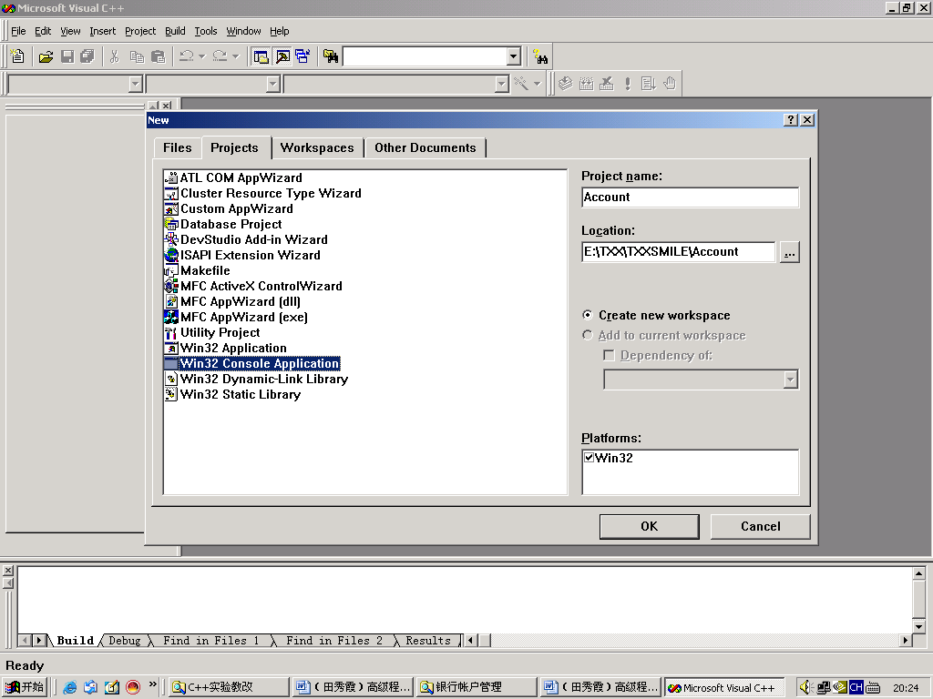
2．将所有的已经创建的扩展名为cpp文件和扩展名为.h文件添加到步骤1所创建的工程中对应的Source Files和Header Files中。如图2所示。
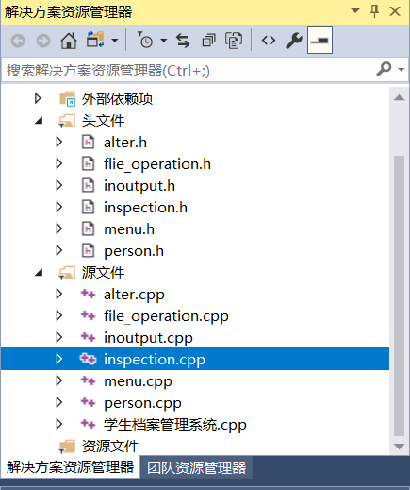

4.2 操作步骤
3．编译每个扩展名为.cpp的文件，如果有编译错误，则根据提示修改，否则编译成功。最后编译、连接和运行测试程序文件，输入数据并测试程序的各种操作。如图3所示。
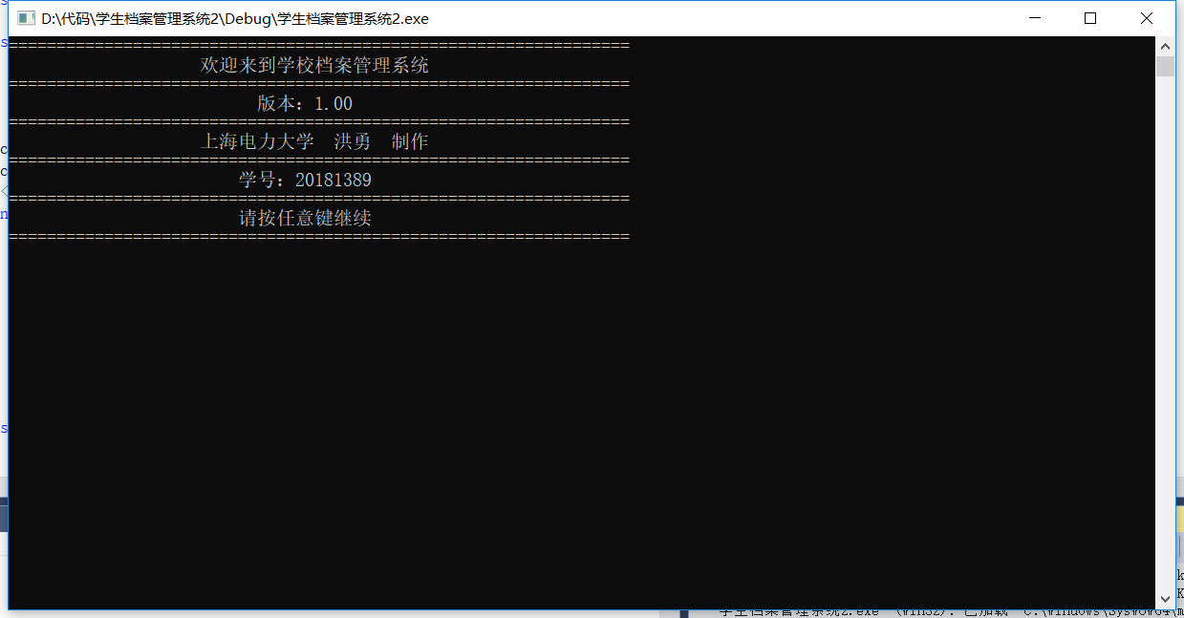

4．单击回车。则出现如图4所示。
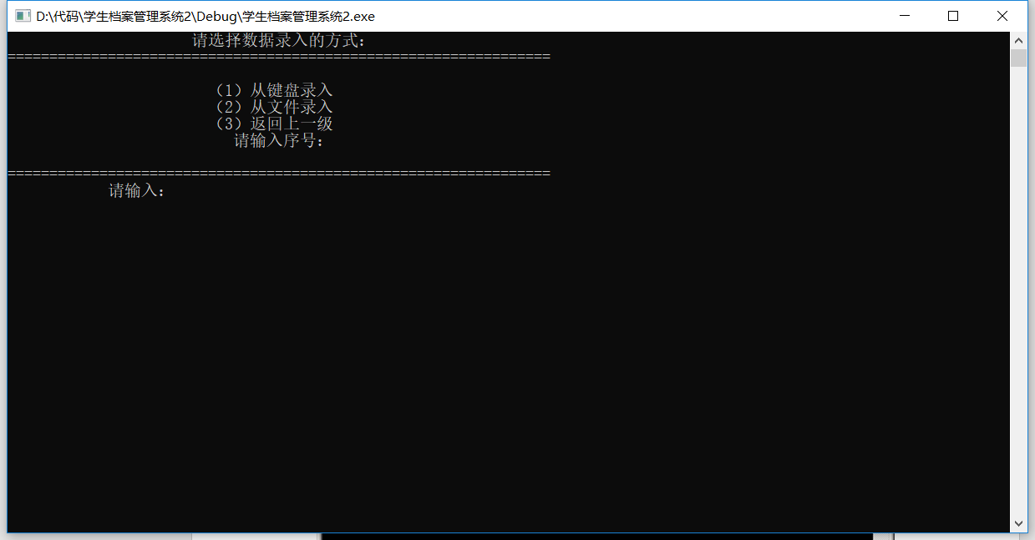
5．在当前的Dos窗口中，输入要执行的功能号码，如输入2然后单击回车，则显示如图5所示。
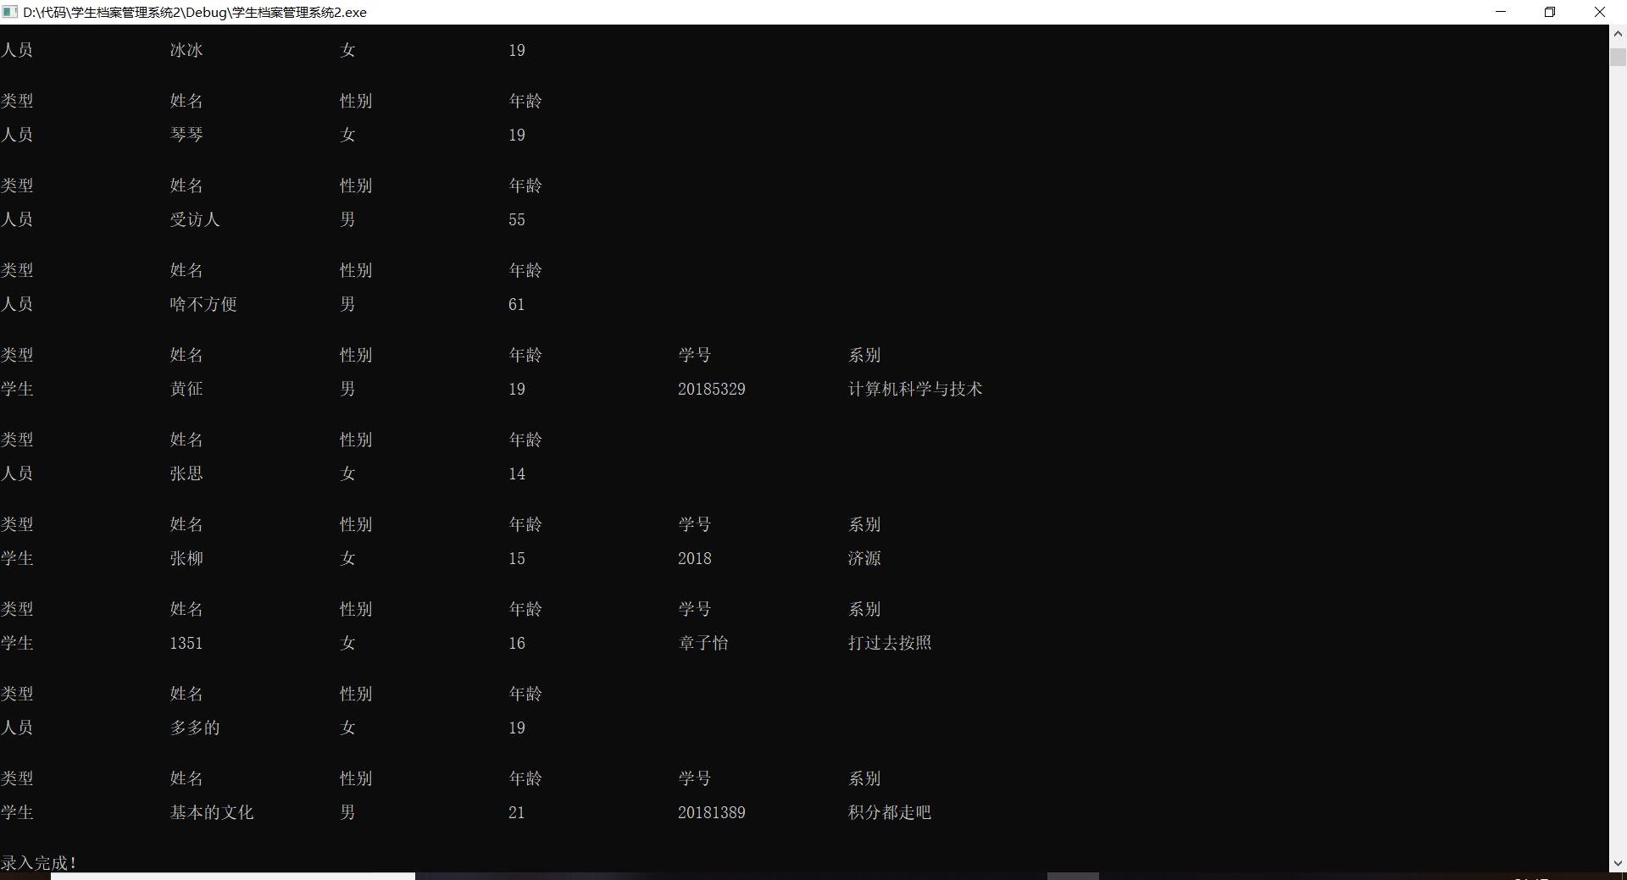
6．点击回车，如图6所示。
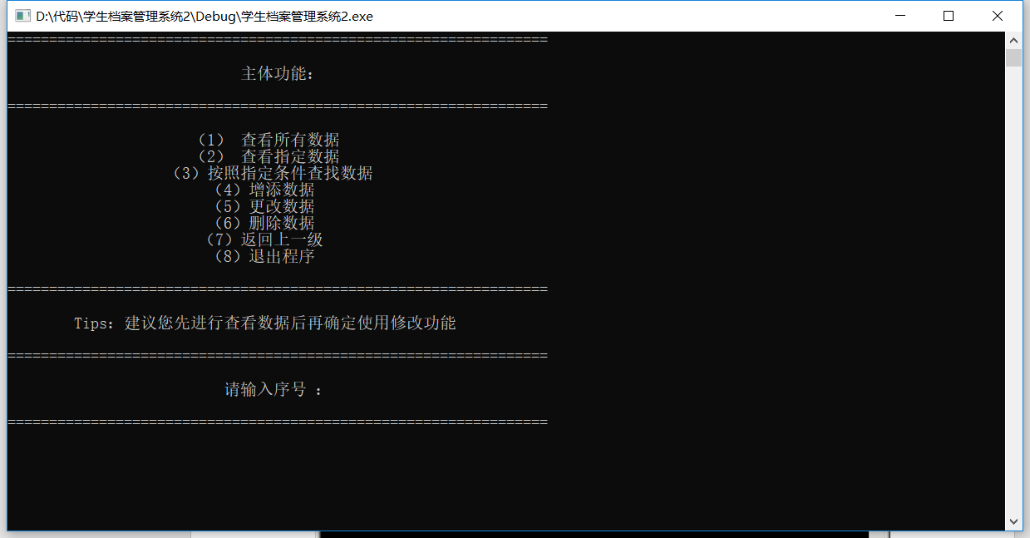
7．如果想查看所有数据，则输入1，然后单击回车，此时出现如图7，显示所有录入数据与执行操作。
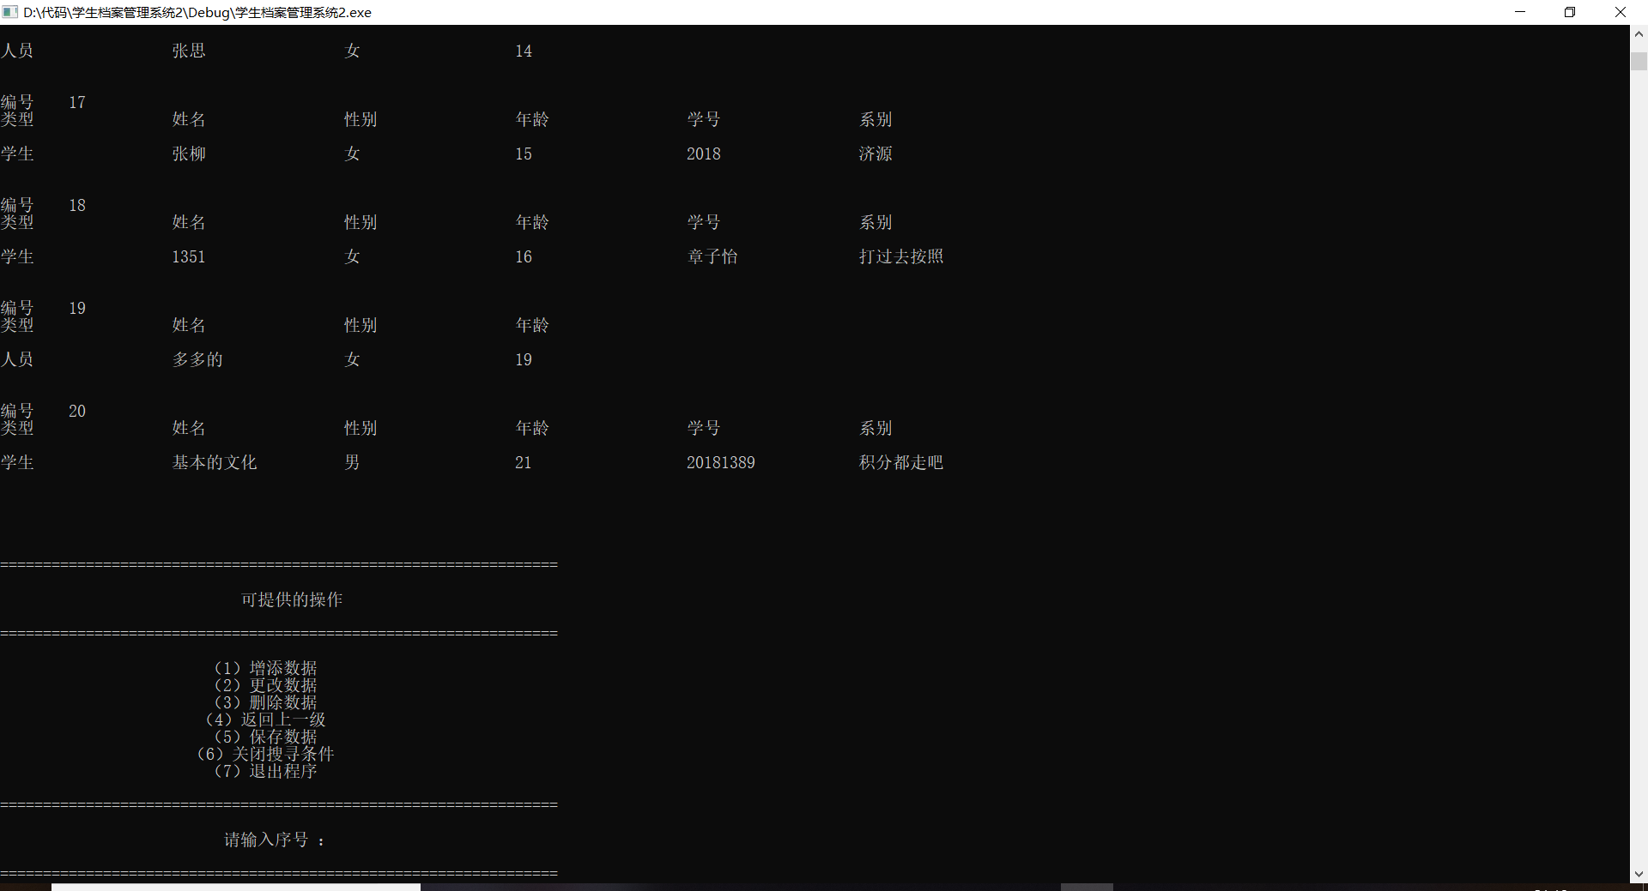
8．若输入功能号码2，然后单击回车，则出现如图8所示内容，显示您选择查看的数据编号，可以继续选择功能号码。
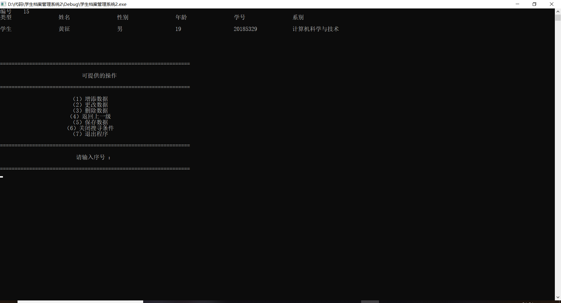

9．输入功能号码3，然后单击回车，则出现如图9所示，要求选择查找模式，输入相应的信息后，显示搜查结果，可以继续选择功能号码。
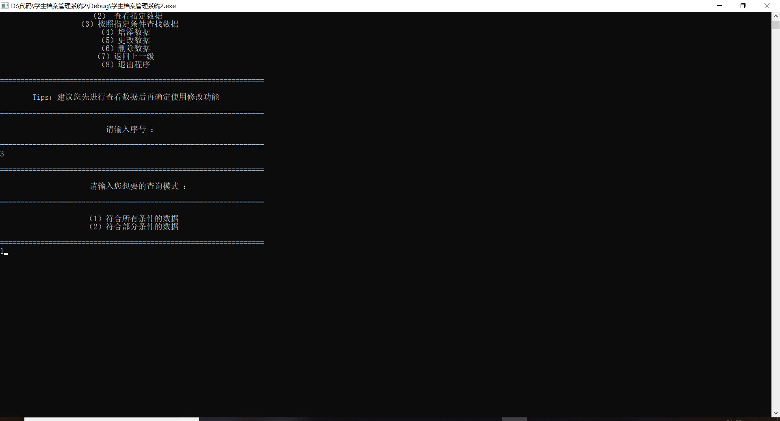
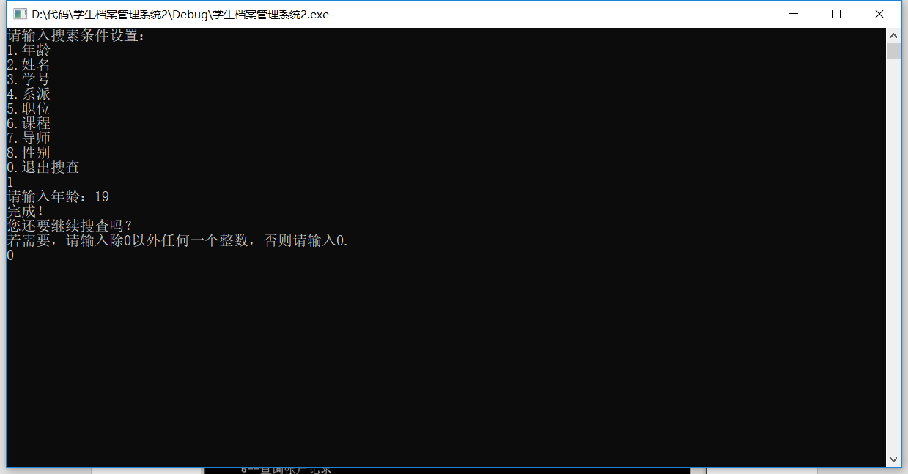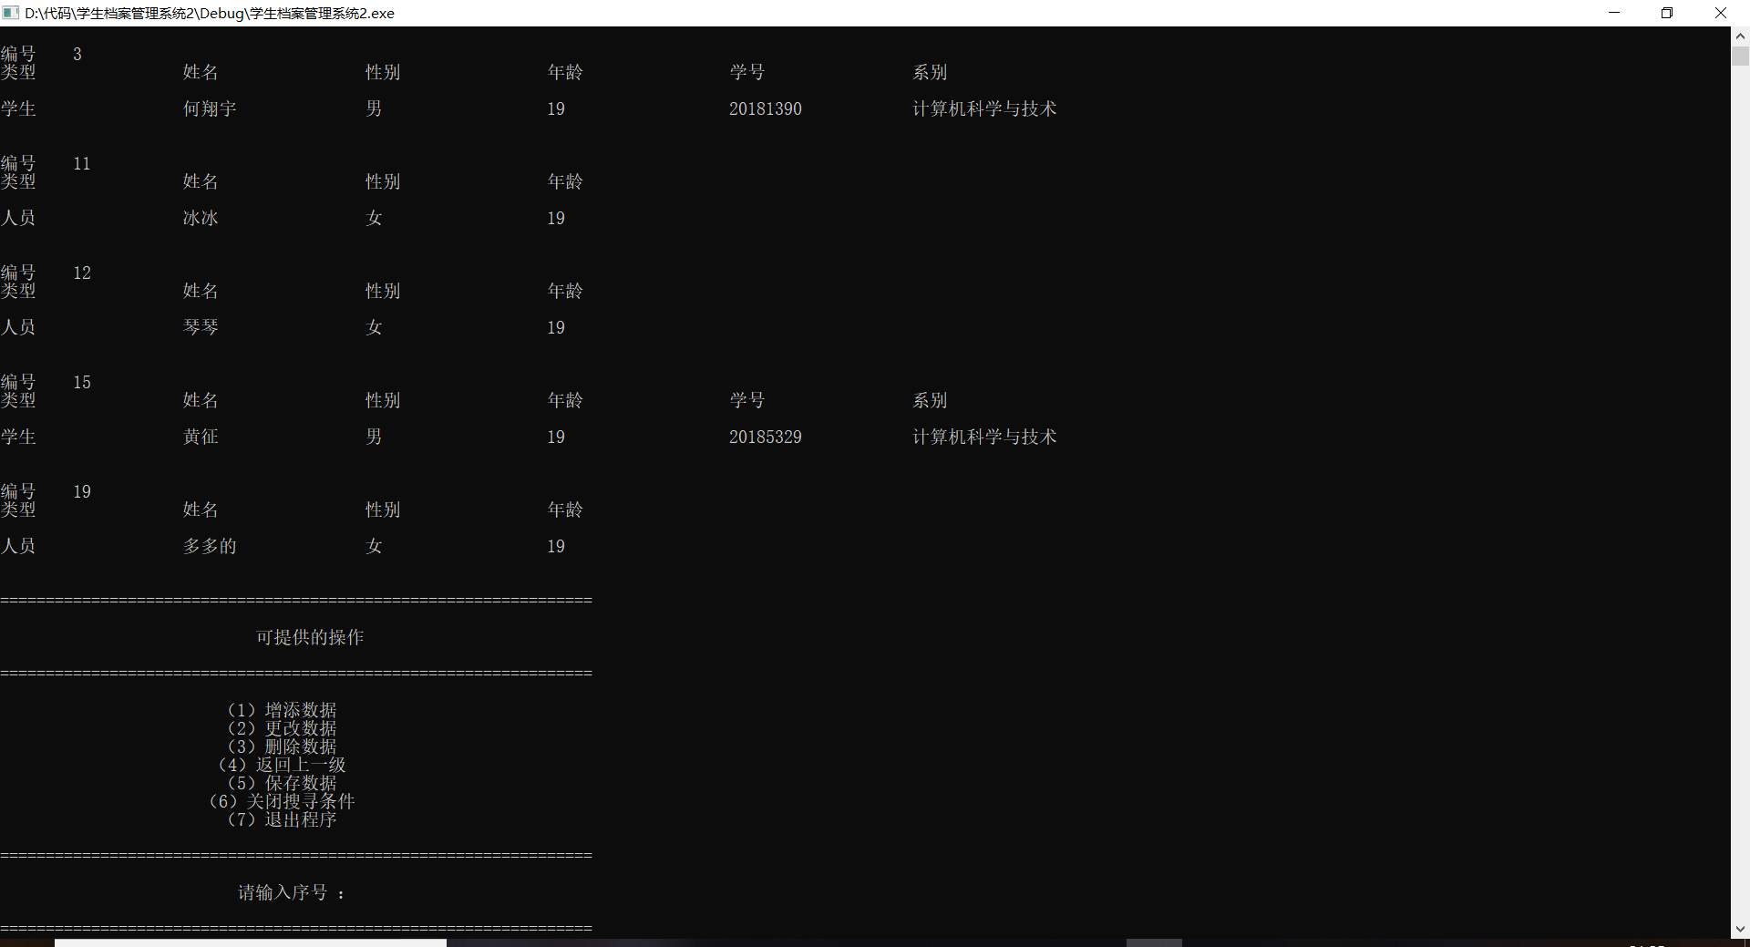

10．输入功能号码4，然后单击回车，则出现如图10所示，可以增添数据，可以继续选择功能号码。
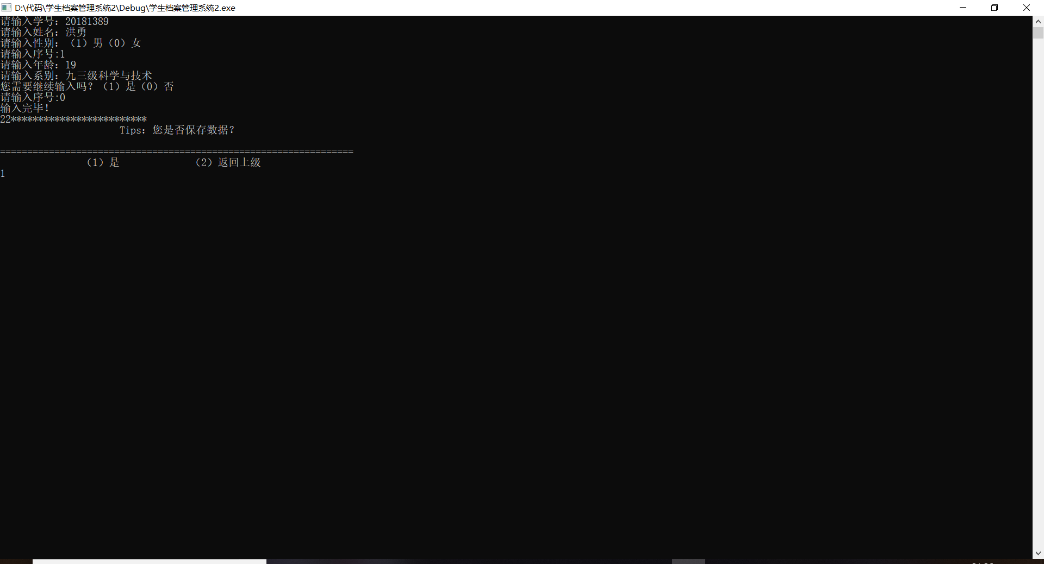
11．输入功能号码5，然后单击回车，则出现如图11所示。可以修改数据，可以继续选择功能号码。
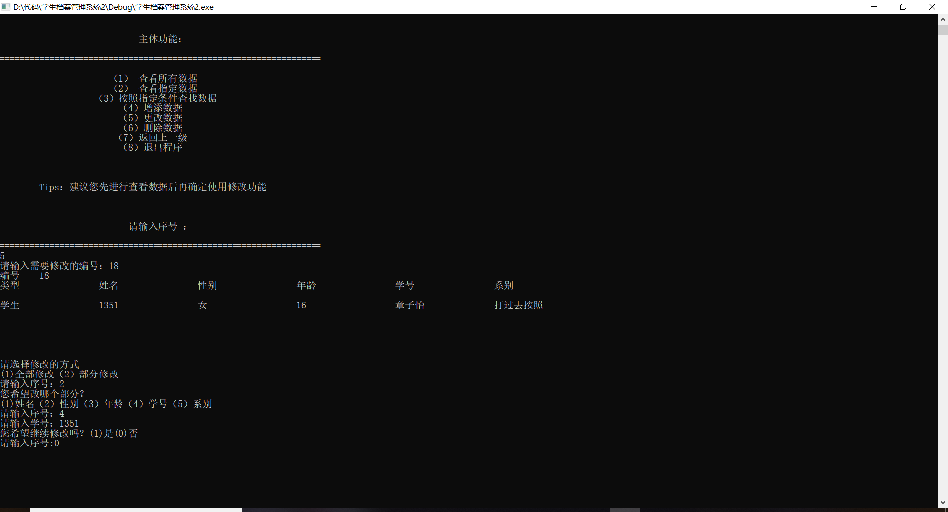
12．输入功能号码6，然后单击回车，则出现如图12所示。可以删除数据，可以继续选择功能号码。
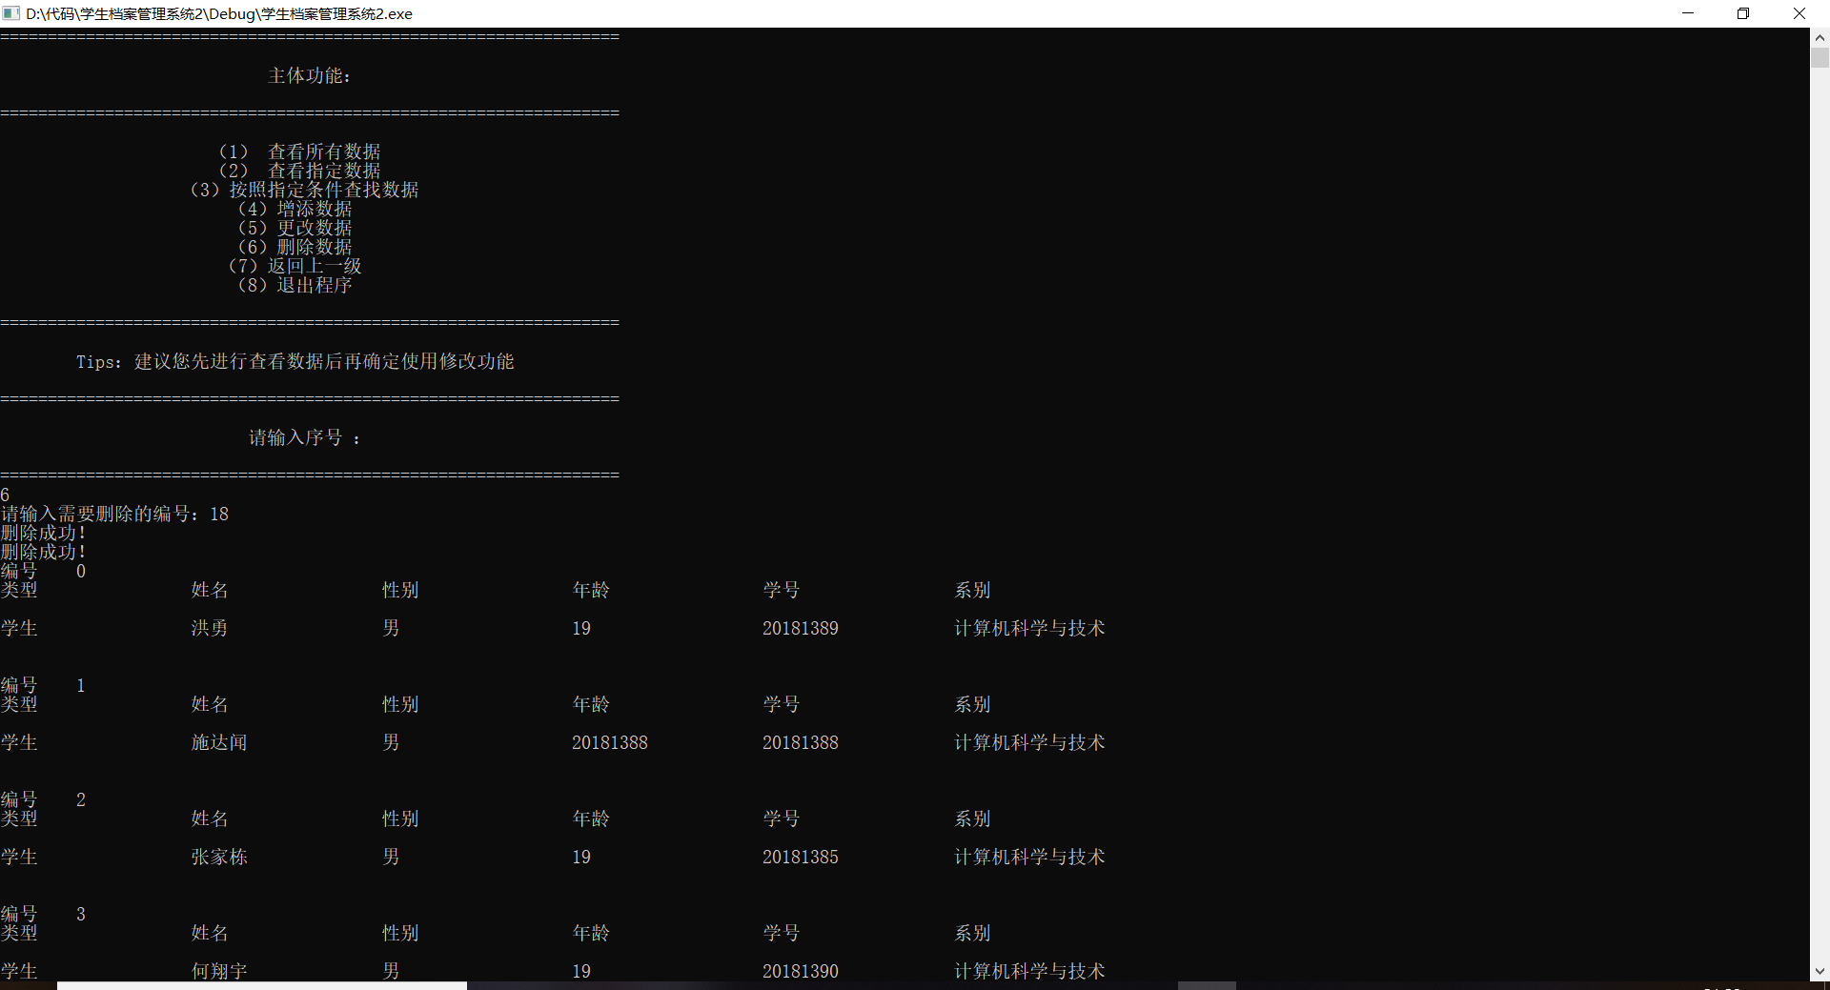
13．在任意一步操作后，输入功能号码5，然后单击回车，则出现如图13所示。可以把数据保存并写入storage.txt中，可以继续选择功能号码。
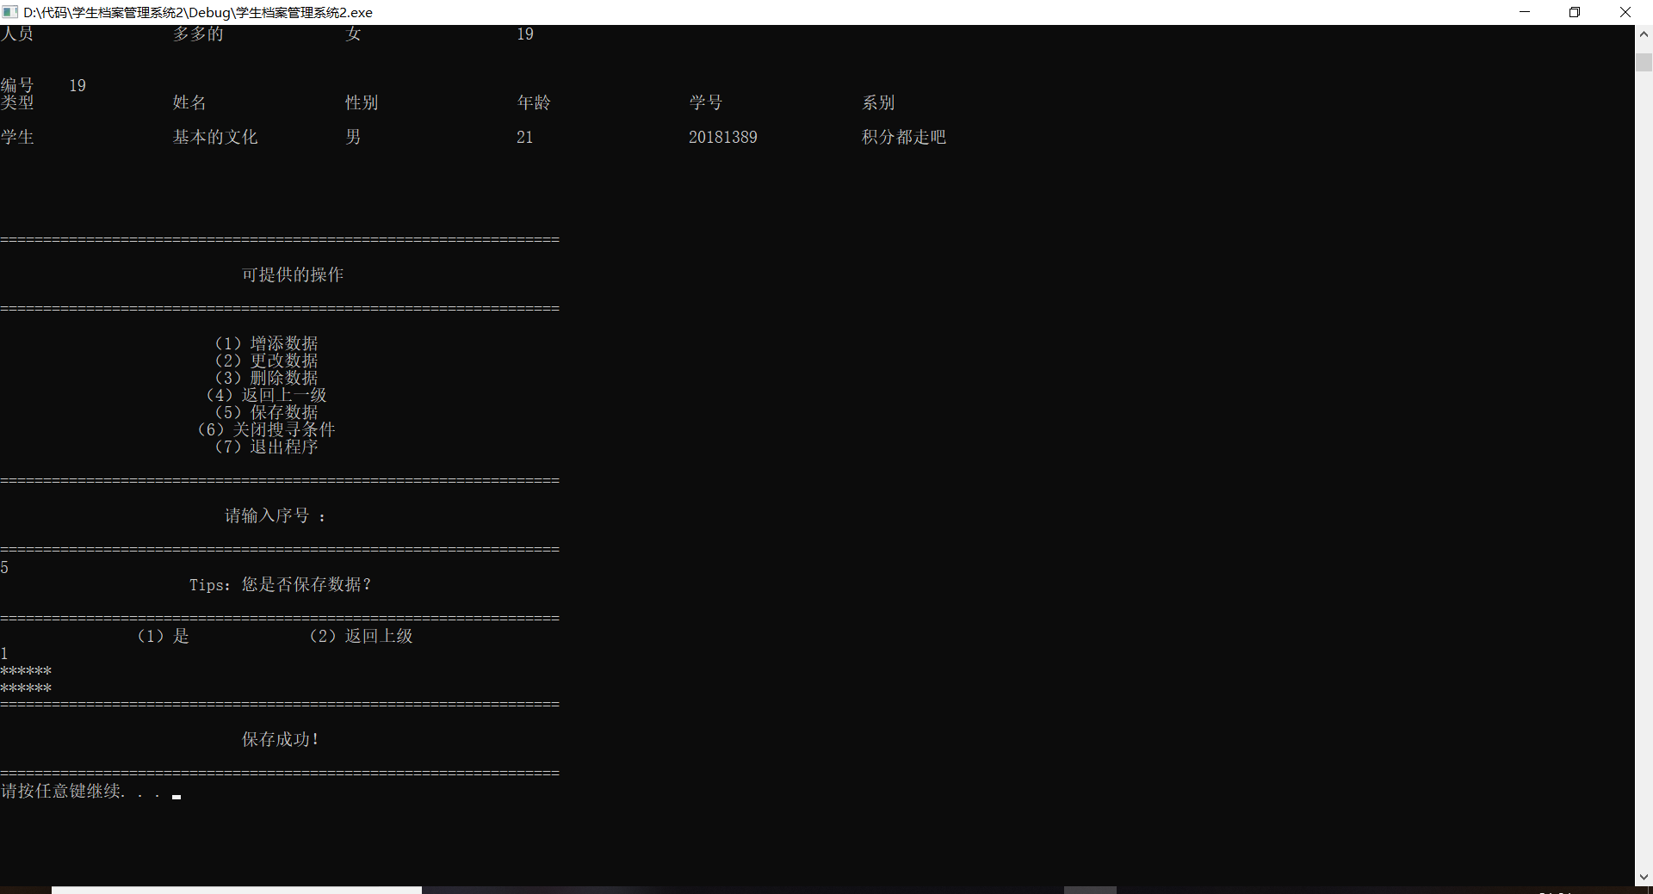

14．输入功能号码8，然后单击回车，则出现如图14所示。会弹出是否保存，再确认是否退出程序。
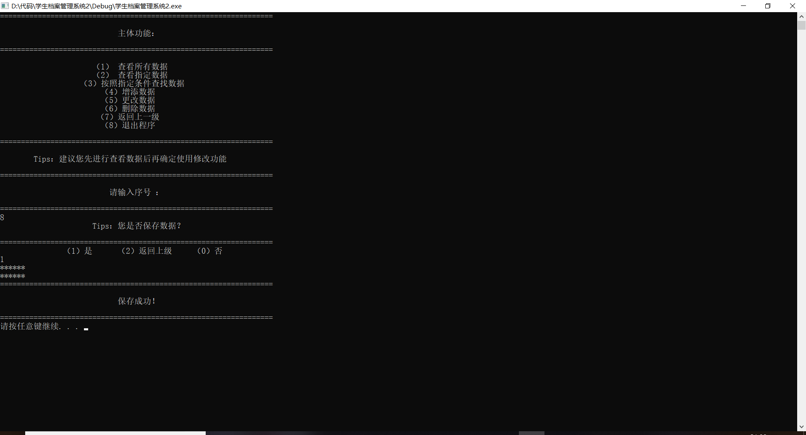

程序创新点
- 可实现从txt文件中读取，从键盘读取两个功能，能让用户自由选择读取方式。
- 可实现保存到txt功能，每做一次数据调整都能让用户选择保存到txt文件中而不怕数据忘记保存。
- 能够随时添加或删除数据，并随时保存。
- 更改数据的方式提供2种，一种是全部修改，一种是只改一项内容。
- 搜寻方式提供两种，一种为符合全部输入条件的搜查，一种为仅需符合部分条件的搜查。前者可以把全部完全符合条件的数据全部输出，后者只要符合其中的一个或以上的条件都会输出。
- 如果用户对条件记忆很模糊，可以多次输入同一条件，如果满足多个同一条件的中的一个条件，都可以将数据输出出来。
- 假如用户输完条件后发现还可以添加几个条件，可以通过返回上一级再加入条件，无需再把之前的条件再重新输入一遍。
- 退出程序会提示用户保存数据，不会直接退出程序。
- 每一步操作后，都会提供给用户下一步可以进行的操作，例如在查找数据之后，用户可以紧接着进行修改，保存，删除等等操作。

使用的主要技术
- 利用虚函数实现动态绑定，实现了多态性。
- 使用嵌套将函数全部链接起来。
- 利用bool类成员实现搜查部分的算法，使其能提供两种不同的搜索方式。
- 使用文件输入输出流从txt文件录入数据以及保存数据到txt文件中。
- 利用数组进行数据的存放。
- 使用成员函数进行对对象的数据输入与输出。

总结
- 虚函数可以实现动态绑定。继承之后，在父类定义一个虚函数，再在子类进行重新定义，就实现了基类与子类的动态绑定。我们这时可以对通过声明基类，再按需进行分配内存空间，就可以实现统一接口进行的不同行为。接口的统一方便进行数据的管理。通过对象的多态性，可以不用针对每个子类写相应的操作函数，可以仅仅写一个函数来对对象进行操作，便于操作与管理。
- 成员函数调用时，可能不是操作对应数组位置的成员。因此会出现即使构造函数中即使初始化了对象成员，调用时会导致true=205这种奇怪情况。这是因为c++对对象进行编译时，并不会给每个对象的函数都分配内存空间，而是只开辟一处内存空间来储存成员函数。这块内存空间是公用的成员函数空间。所以如果成员函数没有收到指针指向的内存地址，成员函数的操作将不受编写者的控制，不会按照操作者的意图来操作对应的成员。要么就是给成员函数添加指针，要么就是使用函数来实现功能。
- 搜查部分的算法是由本人自己设计实现的，我在此总结一下实现原理。首先我给每个对象的每个数据都设置了2个bool类型的数据，用于判断。例如，student类我定义了姓名，性别，年龄，派系，学号等等，它们每个数据还有2个bool数据连接在一起。我先将所有的bool数据初始化为true。当搜索模式为符合所有条件时，函数对成员进行检测，首先检测数据的第一个bool类型数据是否为true，如果为true，这说明没被找到过，再检测成员数据是否对应，若对应，对应的第一个bool类型数据赋值为false，对应的第二个bool类型赋值为true；若不对应，对应的第一个bool类型数据赋值为true，对应的第二个bool类型赋值为false；如果第一个bool类型数据为false，说明之前被找到过，跳过这个数据对下一个数据进行查找。当所有数据都被搜寻过后，检测第二个bool类型数据是否全为true，如果是，则输出；不是，则跳过。这样写，当用户对某个条件记忆模糊的话，可以多次输入类似的词语，只要其中有一个以上是正确的就会输出。当搜索模式为符合部分条件时，同样对类型数据是否为true，如果为true，这说明没被找到过，再检测成员数据是否对应，若对应，则将第一个bool数据全部赋值为false，第二个bool类型数据全部赋值为true。反之与上面相同。这个模式，只要有其中一个符合，就会被全部输出。第一个bool类型数据起到的是打开和关闭更改权限的作用，第二个bool类型的数据起到的是显示查找结果的作用。
- 在文件读写当中，peek（）函数不会读多一行，会预判结束位置然后结束。
- 在读文件中，我们可以考虑将一行都读进来，再进行字符串分割，可以不用fseek来手动选取读写位置。

附录
主要程序代码
person.h
#pragma once
#ifndef PERSON_H
#define PERSON_H
#include <iostream>
#include <string>
#include<fstream>
using namespace std;
class base_massage {
public:
string name;
bool sex;
int age;
};

class person {
private:
base_massage b_m;
public:
bool inspection_name;
bool inspection_sex;
bool inspection_age;
bool inspection_number;
bool inspection_department;
bool inspection_perfessor;
bool inspection_course;
bool inspection_tutor;
bool inspection_name_1;
bool inspection_sex_1;
bool inspection_age_1;
bool inspection_number_1;
bool inspection_department_1;
bool inspection_perfessor_1;
bool inspection_course_1;
bool inspection_tutor_1;

public:
person();
virtual int input() ;
virtual void output();
virtual void alter();
virtual string getname();
virtual bool getsex();
virtual int getage();
virtual string set_name(string a);
virtual bool set_sex(bool a);
virtual int set_age(int a);
virtual string set_number(string a);
virtual string set_department(string a);
virtual string set_perfessor(string a);
virtual string set_course(string a);
virtual string set_tutor(string a);
virtual string getnumber();
virtual string getdepartment();
virtual string getperfessor();
virtual string getcourse();
virtual string gettutor();
virtual void file_input();

};

class student :public person {
private:
base_massage b_m;
string number;
string department;
public:
student();
virtual int input();
virtual void output();
virtual void alter();
virtual string set_name(string a);
virtual bool set_sex(bool a);
virtual int set_age(int a);
virtual string set_number(string a);
virtual string set_department(string a);
virtual string set_perfessor(string a);
virtual string set_course(string a);
virtual string set_tutor(string a);
virtual string getname();
virtual bool getsex();
virtual int getage();
virtual string getnumber();
virtual string getdepartment();
virtual void file_input();
};

class teacher :public person {
private:
base_massage b_m;
string perfessor;
string course;
public:
teacher();
virtual int input();
virtual void output();
virtual void alter();
virtual string set_name(string a);
virtual bool set_sex(bool a);
virtual int set_age(int a);
virtual string set_number(string a);
virtual string set_department(string a);
virtual string set_perfessor(string a);
virtual string set_course(string a);
virtual string set_tutor(string a);
virtual string getname();
virtual bool getsex();
virtual int getage();
virtual string getperfessor();
virtual string getcourse();
virtual void file_input();
};

class graduatestudent :public student {
private:
base_massage b_m;
string number;
string department;
string tutor;
public:
graduatestudent();
virtual int input();
virtual void output();
virtual void alter();
virtual string set_name(string a);
virtual bool set_sex(bool a);
virtual int set_age(int a);
virtual string set_number(string a);
virtual string set_department(string a);
virtual string set_perfessor(string a);
virtual string set_course(string a);
virtual string set_tutor(string a);
virtual string getname();
virtual bool getsex();
virtual int getage();
virtual string getnumber();
virtual string getdepartment();
virtual string gettutor();
virtual void file_input();
};
#endif
person.cpp
#include "person.h"
#include<iostream>
#include<string>
#include <stdlib.h>
#include<algorithm>
#include <iomanip>
#include<fstream>
using namespace std;
//person class
int person::input() {system("cls");cout << "请输入姓名：";cin >> b_m.name;
cout << "请输入性别：（1）男（0）女" << endl;cout << "请输入序号:";
int i = 0;cin >> i;while (i!=1&&i!=0){
cout << " 您输入有误！请重新输入！ " << endl;
cout << "=================================================================" << endl;
cout << endl << endl << endl;
cout << "请输入序号:";
cin >> i;}
if (i == 1)
b_m.sex = true;
else
b_m.sex = false;cout << "请输入年龄：";cin >> b_m.age;return 0;}
void person::output() {cout << setw(20) << left<< "类型" << setw(20) << "姓名" << setw(20) <<
"性别" << setw(20) << "年龄" << setw(20) << endl;
cout << endl;
cout << setw(20) << left << "人员";
cout << setw(20) << left << b_m.name;
if (b_m.sex)
cout << setw(20) << left<<"男";
else
cout << setw(20) << left<<"女";
cout << setw(20) << left << b_m.age << endl << endl << endl;}
void person::alter() {
int temp;
cout << "请选择修改的方式" << endl;
cout << "(1)全部修改（2）部分修改" << endl;
cout << "请输入序号：";
cin >> temp;
int flag = 1;
while (flag == 1){
if (temp == 1)
input();
else if (temp == 2) {
int choice;cout << "您希望改哪个部分？" << endl;
cout << "(1)姓名（2）性别（3）年龄" << endl;cout << "请输入序号：";
cin >> choice;
if (choice == 1) {cout << "请输入姓名：";cin >> b_m.name;}
else if (choice == 2) {cout << "请输入性别：（1）男（0）女" << endl;
cout << "请输入序号:";cin >> b_m.sex;}
else if (choice == 3) {cout << "请输入年龄：";cin >> b_m.age;}
else {cout << "您输入有误！";continue;}}
else {cout << "您输入有误！";continue;}cout << "您希望继续修改吗？";
cout << "(1)是(0)否" << endl;cout << "请输入序号:";cin >> flag;}
cout << "修改完成！" << endl;}
string person::set_name(string a) {b_m.name = a;return b_m.name;};//
bool person::set_sex(bool a) {b_m.sex = a;return b_m.sex;};//
int person::set_age(int a) {b_m.age = a;return b_m.age;};//
string person::set_number(string a) {return "";};//
string person::set_department(string a) {return "";};//
string person::set_perfessor(string a) {return "";};//
string person::set_course(string a) {return "";};//
string person::set_tutor(string a) {return "";};//
string person::getname() {return b_m.name;}//
bool person::getsex() {return b_m.sex;}//
int person::getage() {return b_m.age;}//
string person::getnumber() {return " ";}//
string person::getdepartment() {return " ";}//
string person::getperfessor() {return " ";}//
string person::getcourse() {return " ";}//
string person::gettutor() {return " ";}//
void person::file_input() {ofstream open("storage.txt", ios::app);
if (!open)
cout << "打开失败！" << endl;
open << "人员" << "\t";open << b_m.name << "\t";open << b_m.age << "\t";
if(b_m.sex==1)
open << "男" << endl;
else
open << "女" << endl;
open.close();} //
person::person() {inspection_age = true;inspection_course = true;
inspection_department = true;inspection_name = true;inspection_number = true;
inspection_perfessor = true;inspection_sex = true;inspection_tutor_1 = true;
inspection_age_1 = true;inspection_course_1 = true;inspection_department_1 = true;
inspection_name_1 = true;inspection_number_1 = true;inspection_perfessor_1 = true;
inspection_sex_1 = true;inspection_tutor = true;};
//student class
int student::input() {system("cls");cout << "请输入学号：";cin >> number;
cout << "请输入姓名：";cin >> b_m.name;
cout << "请输入性别：（1）男（0）女" << endl;cout << "请输入序号:";int i = 0;
cin >> i;while (i != 1 && i != 0){
cout << " 您输入有误！请重新输入！ " << endl;
cout << "=================================================================" << endl;
cout << endl << endl << endl;cout << "请输入序号:";cin >> i;}
if (i == 1)
b_m.sex = true;
else
b_m.sex = false;
cout << "请输入年龄：";cin >> b_m.age;cout << "请输入系别：";cin >> department;
return 0;};
void student::output() {
cout << left << setw(20) << "类型" << setw(20) << "姓名" << setw(20) <<"性别" << setw(20) << "年龄" << setw(20) << "学号" << setw(20) <<"系别" << endl;
cout << endl;cout << setw(20) << left << "学生";cout << setw(20) << left << b_m.name;
if (b_m.sex)
cout << setw(20) << left<<"男";
else
cout << setw(20) << left<< "女";
cout << setw(20) << left << b_m.age;cout << setw(20) << left << number;
cout << setw(20) << left << department << endl << endl << endl;}
void student::alter() {int temp;
cout << "请选择修改的方式" << endl;cout << "(1)全部修改（2）部分修改" << endl;
cout << "请输入序号：";cin >> temp;int flag = 1;
while (flag == 1){
if (temp == 1) input();
else if (temp == 2) {int choice;cout << "您希望改哪个部分？" << endl;
cout << "(1)姓名（2）性别（3）年龄（4）学号（5）系别" << endl;
cout << "请输入序号：";cin >> choice;
if (choice == 1) {cout << "请输入姓名：";cin >> b_m.name;}
else if (choice == 2) {cout << "请输入性别：（1）男（0）女" << endl;
cout << "请输入序号:";cin >> b_m.sex;}
else if (choice == 3) {cout << "请输入年龄：";cin >> b_m.age;}
else if (choice == 4) {cout << "请输入学号：";cin >> number;}
else if (choice == 5) {cout << "请输入系别：";cin >> department;}
else {cout << "您输入有误！";continue;}}
else {cout << "您输入有误！";continue;}
cout << "您希望继续修改吗？";
cout << "(1)是(0)否" << endl;cout << "请输入序号:";cin >> flag;}
cout << "修改完成！" << endl;}
string student::set_name(string a) {b_m.name = a;return b_m.name;};
bool student::set_sex(bool a) {b_m.sex = a;return b_m.sex;};
int student::set_age(int a) {b_m.age = a;return b_m.age;};
string student::set_number(string a) {number = a;return number;};
string student::set_department(string a) {department = a;return department;};
string student::set_perfessor(string a) {return "";};string student::set_course(string a) {return "";};
string student::set_tutor(string a) {return "";};string student::getname() {return b_m.name;}
bool student::getsex() {return b_m.sex;}int student::getage() {return b_m.age;}
string student::getnumber() {return number;}
string student::getdepartment() {return department;}
student::student() {
inspection_age = true;inspection_course = true;inspection_department = true;
inspection_name = true;inspection_number = true;inspection_perfessor = true;
inspection_sex = true;inspection_tutor = true;inspection_tutor_1 = true;
inspection_age_1 = true;inspection_course_1 = true;inspection_department_1 = true;
inspection_name_1 = true;inspection_number_1 = true;inspection_perfessor_1 = true;
inspection_sex_1 = true;inspection_tutor_1 = true;};
void student::file_input() { ofstream open("storage.txt", ios::app);
if (!open)
cout << "打开失败！" << endl;
open << "学生" << "\t"; open << b_m.name << "\t"; open << b_m.age << "\t";
if (b_m.sex == 1)
open << "男" << "\t";
else
open << "女" << "\t";
open << number << "\t"; open << department << endl; open.close();}
//teacher class
int teacher::input() {system("cls");cout << "请输入姓名：";cin >> b_m.name;
cout << "请输入性别：（1）男（0）女" << endl;cout << "请输入序号：";
int i = 0;cin >> i;while (i != 1 && i != 0){
cout << " 您输入有误！请重新输入！ " << endl;
cout << "=================================================================" << endl;
cout << endl << endl << endl;cout << "请输入序号：";cin >> i;}
if (i == 1)
b_m.sex = true;
else
b_m.sex = false;
cout << "请输入年龄：";cin >> b_m.age;cout << "请输入职称：";cin >> perfessor;
cout << "请输入担任课程：";cin >> course;return 0;}
void teacher::output() {cout << left<< setw(20) << "类型" << setw(20) << "姓名" << setw(20) <<
"性别" << setw(20) << "年龄" << setw(20) << "职称" << setw(20) << "担任课程" << endl;cout << endl;cout << setw(20) << left << "教师";cout << setw(20) << left << b_m.name;
if (b_m.sex)
cout << setw(20) << left<<"男";
else
cout << setw(20) << left<< "女";
cout << setw(20) << left << b_m.age ;cout << setw(20) << left << perfessor ;
cout << setw(20) << left << course << endl << endl << endl;}
void teacher::alter() {int temp;cout << "请选择修改的方式" << endl;
cout << "(1)全部修改（2）部分修改" << endl;cout << "请输入序号：";
cin >> temp;int flag = 1;while (flag){
if (temp == 1)
input();
else if (temp == 2) {
int choice;
cout << "您希望改哪个部分？" << endl;
cout << "(1)姓名（2）性别（3）年龄（4）职称（5）课程" << endl;
cout << "请输入序号：";
cin >> choice;
if (choice == 1) {cout << "请输入姓名：";cin >> b_m.name;}
else if (choice == 2) {
cout << "请输入性别：（1）男（0）女" << endl;
cout << "请输入序号:";cin >> b_m.sex;}
else if (choice == 3) {cout << "请输入年龄：";cin >> b_m.age;}
else if (choice == 4) {cout << "请输入职称：";cin >> perfessor;}
else if (choice == 5) {cout << "请输入担任课程：";cin >> course;}
else {cout << "您输入有误！";continue;}
cout << "您希望继续修改吗？";cout << "(1)是(0)否" << endl;
cout << "请输入序号:";cin >> flag;}
else {cout << "您输入有误！";continue;}}cout << "修改完成！" << endl;}
string teacher::set_name(string a) {b_m.name = a;return b_m.name;};
bool teacher::set_sex(bool a) {b_m.sex = a;return b_m.sex;};
int teacher::set_age(int a) {b_m.age = a;return b_m.age;};
string teacher::set_number(string a) {return "";};
string teacher::set_department(string a) {return "";};
string teacher::set_perfessor(string a) {perfessor = a;return perfessor;};
string teacher::set_course(string a) {course = a;return course;};
string teacher::set_tutor(string a) {return "";};string teacher::getname() {return b_m.name;}
bool teacher::getsex() {return b_m.sex;}int teacher::getage() {return b_m.age;}
string teacher::getperfessor() {return perfessor;}string teacher::getcourse() {return course;}
void teacher::file_input() {ofstream open("storage.txt", ios::app);
if (!open)
cout << "打开失败！" << endl;open << "教师" << "\t";
open << b_m.name << "\t";open << b_m.age << "\t";
if (b_m.sex == 1)
open << "男" << "\t";
else
open << "女" << "\t";open << course << "\t";open << perfessor << endl;open.close();}
teacher::teacher() {inspection_age = true;inspection_course = true;
inspection_department = true;inspection_name = true;inspection_number = true;
inspection_perfessor = true;inspection_sex = true;inspection_tutor = true;
inspection_tutor_1 = true;inspection_age_1 = true;inspection_course_1 = true;
inspection_department_1 = true;inspection_name_1 = true;inspection_number_1 = true;
inspection_perfessor_1 = true;inspection_sex_1 = true;inspection_tutor_1 = true;};
//graduatestudent class
int graduatestudent::input() {system("cls");cout << "请输入学号：";cin >> number;
cout << "请输入姓名：";cin >> b_m.name;cout << "请输入性别：（1）男（0）女" << endl;
cout << "请输入序号：";int i = 0;cin >> i;
while (i != 1 && i != 0){
cout << " 您输入有误！请重新输入！ " << endl;
cout << "=================================================================" << endl;
cout << endl << endl << endl;cout << "请输入序号：";cin >> i;}
if (i == 1)
b_m.sex = true;
else
b_m.sex = false;
cout << "请输入年龄：";cin >> b_m.age;cout << "请输入系别：";cin >> department;
cout << "请输入导师：";cin >> tutor;return 0;};
void graduatestudent::output() {cout << setw(20) << left<<"类型" << setw(20) << "姓名" << setw(20) <<"性别" << setw(20) << "年龄" << setw(20) << "学号" << setw(20) <<"系别" << setw(20) << "导师" << endl;cout << endl;cout << setw(20) << left << "研究生";
cout << setw(20) << left << b_m.name;
if (b_m.sex)
cout << setw(20) << left<<"男";
else
cout << setw(20) << left<<"女";
cout << setw(20) << left << b_m.age;cout << setw(20) << left << number;
cout << setw(20) << left << department;
cout << setw(20) << left << tutor << endl<<endl<<endl;}
void graduatestudent::alter() {int temp;cout << "请选择修改的方式" << endl;
cout << "(1)全部修改（2）部分修改" << endl;cout << "请输入序号：";cin >> temp;
int flag = 1;while (flag == 1){if (temp == 1)
input();
else if (temp == 2) {int choice;cout << "您希望改哪个部分？" << endl;
cout << "(1)姓名（2）性别（3）年龄（4）学号（5）系别（6）导师" << endl;
cout << "请输入序号：";cin >> choice;
if (choice == 1) {cout << "请输入姓名：";cin >> b_m.name;}
else if (choice == 2) {cout << "请输入性别：（1）男（0）女" << endl;
cout << "请输入序号:";cin >> b_m.sex;}
else if (choice == 3) {cout << "请输入年龄：";cin >> b_m.age;}
else if (choice == 4) {cout << "请输入学号：";cin >> number;}
else if (choice == 5) {cout << "请输入系别：";cin >> department;}
else if (choice == 6) {cout << "请输入导师：";cin >> tutor;}
else {cout << "您输入有误！";continue;}}
else {cout << "您输入有误！";continue;}
cout << "您希望继续修改吗？";cout << "(1)是(0)否" << endl;cout << "请输入序号:";
cin >> flag;}cout << "修改完成！" << endl;}
string graduatestudent::set_name(string a) {b_m.name = a;return b_m.name;};
bool graduatestudent::set_sex(bool a) {b_m.sex = a;return b_m.sex;};
int graduatestudent::set_age(int a) {b_m.age = a;return b_m.age;};
string graduatestudent::set_number(string a) {number = a;return number;};
string graduatestudent::set_department(string a) {department = a;return department;};
string graduatestudent::set_perfessor(string a) {return "";};
string graduatestudent::set_course(string a) {return "";};
string graduatestudent::set_tutor(string a) {tutor = a;return tutor;};
string graduatestudent::getname() {return b_m.name;}
bool graduatestudent::getsex() {return b_m.sex;}int graduatestudent::getage() {return b_m.age;}
string graduatestudent::getnumber() {return number;}
string graduatestudent::getdepartment() {return department;}
string graduatestudent::gettutor() {return tutor;}
void graduatestudent::file_input() {
ofstream open("storage.txt", ios::app);
if (!open)
cout << "打开失败！" << endl;
open << "本科生" << "\t";open << b_m.name << "\t";open << b_m.age << "\t";
if (b_m.sex == 1)
open << "男" << "\t";
else
open << "女" << "\t";open << number << "\t";open << department << "\t";
open << tutor << endl;open.close();}
graduatestudent::graduatestudent() {inspection_age = true;inspection_course = true;
inspection_department = true;inspection_name = true;inspection_number = true;
inspection_perfessor = true;inspection_sex = true;inspection_tutor = true;
inspection_tutor_1 = true;inspection_age_1 = true;inspection_course_1 = true;
inspection_department_1 = true;inspection_name_1 = true;inspection_number_1 = true;
inspection_perfessor_1 = true;inspection_sex_1 = true;inspection_tutor_1 = true;};
Inspection.h
#pragma once
#ifndef INSPECCTION_H #define INSPECCTION_H #include<algorithm>
#include <iomanip> using namespace std;
void inspection_age(person*per[], int* count, int age, int a);
void inspection_name(person*per[], int* count, string name, int a);
void inspection_number(person*per[], int* count, string number, int a);
void inspection_department(person*per[], int* count, string department, int a);
void inspection_perfessor(person*per[], int* count, string perfessor, int a);
void inspection_course(person*per[], int* count, string course, int a);
void inspection_tutor(person*per[], int* count, string tutor, int a);
void inspection_sex(person*per[], int* count, bool sex, int a);
void inspection(person*per[], int* count, int a);void inspection_zero(person*per[], int a);
void inspection_close(person*per[], int a);void inspection_open(person*per[], int a);
#endif // ! INSPECCTION
Inspection.cpp
#include "person.h" #include"inspection.h" #include"menu.h" #include<iostream>
#include<cstdio> #include<string> #include <stdlib.h> #include<algorithm>
#include <iomanip> using namespace std;
//imspection
void inspection_age(person*per[], int* count, int age, int a) {
for (int i = 0; i < *count; i++) {
if (per[i]->getage() == age && per[i]->inspection_age_1 == true) {
per[i]->inspection_age = true;
if (a == 1)
per[i]->inspection_age_1 = false;
else {inspection_close(per, i);inspection_open(per, i);}}
else if (per[i]->inspection_age_1 == false);
else
per[i]->inspection_age = false;}cout << "完成！" << endl;}
void inspection_name(person*per[], int* count, string name, int a) {
for (int i = 0; i < *count; i++) {
if (name.compare(per[i]->getname()) == 0 && per[i]->inspection_name_1 == true) {
per[i]->inspection_name = true;
if (a == 1)
per[i]->inspection_name_1 = false;
else {inspection_close(per, i);inspection_open(per, i);}}
else if (per[i]->inspection_name_1 == false);
else
per[i]->inspection_name = false;}}
void inspection_number(person*per[], int* count, string number, int a) {
for (int i = 0; i < *count; i++) {
if (number.compare(per[i]->getnumber()) == 0 && per[i]->inspection_number_1 == true) {per[i]->inspection_number = true;
if (a == 1)
per[i]->inspection_number_1 = false;
else {inspection_close(per, i);inspection_open(per, i);}}
else if ( per[i]->inspection_number_1 == false);
else
per[i]->inspection_number = false;}}
void inspection_department(person*per[], int* count, string department, int a) {
for (int i = 0; i < *count; i++) {
if (department.compare(per[i]->getdepartment()) == 0 && per[i]->inspection_department_1 == true) {per[i]->inspection_department = true;
if (a == 1)
per[i]->inspection_department_1 = false;
else {inspection_close(per, i);inspection_open(per, i);}}
else if ( per[i]->inspection_department_1 == false);
else
per[i]->inspection_department = false;}}
void inspection_perfessor(person*per[], int* count, string perfessor, int a) {
for (int i = 0; i <* count; i++) {
if (perfessor.compare(per[i]->getperfessor()) == 0 && per[i]->inspection_perfessor_1 == true) {per[i]->inspection_perfessor = true;
if (a == 1)
per[i]->inspection_perfessor_1 = false;
else {inspection_close(per, i);inspection_open(per, i);}}
else if ( per[i]->inspection_perfessor_1 == false);
else
per[i]->inspection_perfessor = false;}}
void inspection_course(person*per[], int* count, string course, int a) {
for (int i = 0; i < *count; i++) {
if (course.compare(per[i]->getcourse()) == 0 && per[i]->inspection_course_1 == true) {per[i]->inspection_course = true;
if (a = 1)
per[i]->inspection_course_1 = false;
else {inspection_close(per, i);inspection_open(per, i);}}
else if ( per[i]->inspection_course_1 == false);
else
per[i]->inspection_course = false;}}
void inspection_tutor(person*per[], int* count, string tutor, int a) {
cout << "***********" << endl;
for (int i = 0; i < *count; i++) {
if (tutor.compare(per[i]->gettutor()) == 0 && per[i]->inspection_tutor_1 == true) {per[i]->inspection_tutor = true;
if (a == 1)
per[i]->inspection_tutor_1 = false;
else {inspection_close(per, i);inspection_open(per, i);}}
else if (tutor.compare(per[i]->gettutor()) != 0 && per[i]->inspection_tutor_1 == true) ;
else if ( per[i]->inspection_tutor_1 == false);
else
per[i]->inspection_tutor = false;}}
void inspection_sex(person*per[], int *count, bool sex, int a) {
for (int i = 0; i < *count; i++) {
if (per[i]->getsex() == sex && per[i]->inspection_sex_1 == true) {
per[i]->inspection_sex = true;
if (a == 1)
per[i]->inspection_sex_1 = false;
else {
inspection_close(per, i);
inspection_open(per, i);}}
else if ( per[i]->inspection_sex_1 == false);
else
per[i]->inspection_sex = false;}}
void inspection(person* per[], int* count,int a) {int choice = 9;int flag = 0;
while (choice != 0) {cout << "请输入搜索条件设置：" << endl;
cout << "1.年龄" << "\n" << "2.姓名" << "\n" << "3.学号" << "\n" << "4.系派" << "\n" << "5.职位"<< "\n" << "6.课程" << "\n" << "7.导师" << "\n" << "8.性别" << "\n" << "0.退出搜查" << "\n";cin >> choice;
switch (choice){case 1: {cout << "请输入年龄：";int age = 0;cin >> age;
inspection_age(per, &*count, age,a);break;}
case 2: {cout << "请输入姓名：";string name;cin >> name;
inspection_name(per, &*count, name, a);break;}
case 3: {cout << "请输入学号：";string number;cin >> number;
inspection_number(per, &*count, number, a);break;}
case 4: {cout << "请输入系派：";string department;cin >> department;
inspection_department(per, &*count, department, a);break;}
case 5: {cout << "请输入职称：";string perfessor;cin >> perfessor;
inspection_perfessor(per,&*count, perfessor, a);break}
case 6: {cout << "请输入担任课程：";string course;cin >> course;
inspection_course(per, &*count, course, a);break;}
case 7: {cout << "请输入担任导师：";string tutor;cin >> tutor;
inspection_tutor(per, &*count, tutor, a);break;}
case 8: {cout << "请输入担任性别：";bool sex;cin >> sex;
inspection_sex(per,&* count, sex, a);break;}
case 0: {break;}
default:break;}cout << "您还要继续搜查吗？" << endl;
cout << "若需要，请输入除0以外任何一个整数，否则请输入0." << endl;cin >> choice;}
system("cls");for (int i = 0; i < *count; i++) {
if (per[i]->inspection_age&&per[i]->inspection_name&&per[i]->inspection_sex&&per[i]->inspection_department&&per[i]->inspection_course&&per[i]->inspection_perfessor&&per[i]->inspection_tutor&&per[i]->inspection_number) {cout << "编号\t" << i << endl;
per[i]->output();flag = 1;}}
if (flag == 0) {
cout << "=================================================================" << endl;
cout << " " << endl;
cout << " 没有符合要求的数据 " << endl;
cout << " " << endl;
cout << "=================================================================" << endl;}menu_alter(per, &*count);}
void inspection_zero(person*per[], int a) {per[a]->inspection_age = true;
per[a]->inspection_course = true;per[a]->inspection_department = true;
per[a]->inspection_name = true;per[a]->inspection_number = true;
per[a]->inspection_perfessor = true;per[a]->inspection_sex = true;
per[a]->inspection_tutor = true;per[a]->inspection_tutor_1 = true;
per[a]->inspection_age_1 = true;per[a]->inspection_course_1 = true;
per[a]->inspection_department_1 = true;per[a]->inspection_name_1 = true;
per[a]->inspection_number_1 = true;per[a]->inspection_perfessor_1 = true;
per[a]->inspection_sex_1 = true;}
void inspection_close(person*per[], int a) {per[a]->inspection_tutor_1 = false;
per[a]->inspection_age_1 = false;per[a]->inspection_course_1 = false;
per[a]->inspection_department_1 = false;per[a]->inspection_name_1 = false;
per[a]->inspection_number_1 = false;per[a]->inspection_perfessor_1 = false;
per[a]->inspection_sex_1 = false;}
void inspection_open(person*per[], int a) {per[a]->inspection_tutor = true;
per[a]->inspection_age = true;per[a]->inspection_course = true;
per[a]->inspection_department = true;per[a]->inspection_name = true;
per[a]->inspection_number = true;per[a]->inspection_perfessor = true;
per[a]->inspection_sex = true;}
Alter.h
#pragma once #ifndef ALTER_H #define ALTER_H #include "person.h" #include"menu.h"
#include"alter.h" #include"inspection.h" #include"inoutput.h"#include"flie_operation.h"
#include<iostream> #include<string> #include <stdlib.h> using namespace std;
void alter_information(person* per[], int* count);
void delete_information(person* per[],int* count); #endif
Alter.cpp
#include "person.h" #include"menu.h" #include"alter.h" #include"inspection.h"
#include"inoutput.h" #include"flie_operation.h" #include<iostream>
#include<string> #include <stdlib.h> using namespace std;
void alter_information(person* per[],int* count) {cout << "请输入需要修改的编号：";
int i = 0;cin >> i;while (i >= *count) {
cout << " 您输入有误！请重新输入！ " << endl;
cout << "=================================================================" << endl;cout << endl << endl << endl;system("pause");cin >> i;}
inspection_zero(per, i);if (per[i]->inspection_name == true && per[i]->inspection_course == true && per[i]->inspection_department == true&& per[i]->inspection_number == true && per[i]->inspection_perfessor == true && per[i]->inspection_tutor == true) {cout << "编号\t" << i << endl;
per[i]->output();}cout << endl << endl << endl;
while (i >= *count) {
cout << " 您输入有误！请重新输入！ " << endl;
cout << "=================================================================" << endl;cout << endl << endl << endl;cin >> i;}per[i]->alter();system("cls");
for (int i = 0; i < *count; i++) {if(per[i]->inspection_age&&per[i]->inspection_name&&per[i]->inspection_sex&&per[i]->inspection_department&&per[i]->inspection_course&&per[i]->inspection_perfessor&&per[i]->inspection_tutor&&per[i]->inspection_number) {cout << "编号\t" << i << endl;
per[i]->output();}}menu_alter(per, &*count);}
void delete_information(person* per[], int* count) {cout << "请输入需要删除的编号：";
int b = 0;cin >> b;if (b == *count - 1) {*count -= 1;cout << "删除成功！" << endl;}
else
for (int a = b; a < *count-1; a++) {*count -= 1;cout << "删除成功！" << endl;
per[a] = per[a + 1];}
for (int i = 0; i < *count; i++) {if(per[i]->inspection_age&&per[i]->inspection_name&&per[i]->inspection_sex&&per[i]->inspection_department&&per[i]->inspection_course&&per[i]->inspection_perfessor&&per[i]->inspection_tutor&&per[i]->inspection_number) {cout << "编号\t" << i << endl;
per[i]->output();}}menu_alter(per, &*count);}
Menu.h
#pragma once #ifndef MENU_F #define MENU_F #include "person.h" #include"menu.h"
#include"alter.h" #include"inspection.h" #include"inoutput.h"
#include"flie_operation.h" #include<iostream> #include<string> #include <stdlib.h>
void menu_welcome(person* per[],int* count);void menu_read(person* per[], int* count);
void menu_main(person* per[], int* count);void menu_alter(person* per[], int* count);
void menu_save(person* per[], int* count);void menu_exit(person* per[], int* count);
#endif // !MENU_F
Menu.cpp
#include "person.h" #include"menu.h" #include"alter.h" #include"inspection.h" #include"inoutput.h" #include"flie_operation.h" #include<iostream>
#include<string> #include <stdlib.h> using namespace std;
void menu_welcome(person* per[], int* count1) {int count = 0;
cout << "=================================================================" << endl;
cout << " 欢迎来到学校档案管理系统 " << endl;
cout << "=================================================================" << endl;
cout << " 版本：1.00 " << endl;
cout << "=================================================================" << endl;
cout << " 上海电力大学 洪勇 制作 " << endl;
cout << "=================================================================" << endl;
cout << " 学号：20181389 " << endl;
cout << "=================================================================" << endl;
cout << " 请按任意键继续 " << endl;
cout << "=================================================================" << endl;getchar();system("cls");menu_read(per,&*count1);}
void menu_read(person* per[], int* count1) {int choice = 0;
cout << " 请选择数据录入的方式： " << endl;
cout << "=================================================================" << endl;
cout << " " << endl;
cout << " （1）从键盘录入 " << endl;
cout << " （2）从文件录入 " << endl;
cout << " （3）返回上一级 " << endl;
cout << " 请输入序号： " << endl;
cout << " " << endl;
cout << "=================================================================" << endl;cout << " 请输入："; cin >> choice;
if (choice == 1)
*count1 = statics_input(per, &*count1);
else if (choice == 2)
file_read(per, &*count1);
else if (choice == 3) {system("cls");menu_welcome(per, &*count1);}
else {cout << " 您输入有误！请重新输入！ " << endl;
cout << "=================================================================" << endl;
system("pause");system("cls");menu_read(per, &*count1);}}
void menu_main(person* per[],int* count) {int choice = 0;
//cout << " 录入成功！ " << endl;
cout << "=================================================================" << endl;
cout << " " << endl;
cout << " 主体功能： " << endl;
cout << " " << endl;
cout << "=================================================================" << endl;
cout << " " << endl;
cout << " （1） 查看所有数据 " << endl;
cout << " （2） 查看指定数据 " << endl;
cout << " （3）按照指定条件查找数据 " << endl;
cout << " （4）增添数据 " << endl;
cout << " （5）更改数据 " << endl;
cout << " （6）删除数据 " << endl;
cout << " （7）返回上一级 " << endl;
cout << " （8）退出程序 " << endl;
cout << " " << endl;
cout << "=================================================================" << endl;
cout << " " << endl;
cout << " Tips：建议您先进行查看数据后再确定使用修改功能 " << endl;
cout << " " << endl;
cout << "=================================================================" << endl;
cout << " " << endl;
cout << " 请输入序号 ： " << endl;
cout << " " << endl;
cout << "=================================================================" << endl;cin >> choice;switch (choice){
case 1: {statics_output(per,&*count);break;}
case 2: {statics_output_1(per, &*count);break;}
case 3: {int a = 0;
cout << " " << endl;
cout << "=================================================================" << endl;
cout << " " << endl;
cout << " 请输入您想要的查询模式 ： " << endl;
cout << " " << endl;
cout << "=================================================================" << endl;
cout << " " << endl;
cout << " （1）符合所有条件的数据 " << endl;
cout << " （2）符合部分条件的数据 " << endl;
cout << " " << endl;
cout << "=================================================================" << endl;
cin >> a;while (a != 1 && a != 2) {
cout << " 您输入有误！请重新输入！ " << endl;
cout << "=================================================================" << endl;
system("pause");
cout << "=================================================================" << endl;
cout << " " << endl;
cout << " 请输入您想要的查询模式 ： " << endl;
cout << " " << endl;
cout << "=================================================================" << endl;
cin >> a;}system("cls");inspection(per, &*count,a);break;}
case 4: {static_add(per, &*count);break;}
case 5: {alter_information(per, &*count);break;}
case 6: {delete_information(per, &*count);break;}
case 7: {menu_read(per, &*count);break;}
case 8: {int a = 0;
cout << " Tips：您是否保存数据？ " << endl;
cout << " " << endl;
cout << "=================================================================" << endl;
cout << " （1）是 （2）返回上级 （0）否 " << endl;cin >> a;
if (a == 0) {system("pause");exit(0);}
else if (a == 1) {file_input(per, *count);
cout << "=================================================================" << endl;
cout << " " << endl;
cout << " 保存成功！ " << endl;
cout << " " << endl;
cout << "=================================================================" << endl;
system("pause");system("cls");exit(0);}
else if (a == 2) {system("cls");menu_main(per, &*count)}}
default: {
cout << " 您输入有误！请重新输入！ " << endl;
cout << "=================================================================" << endl;
cout << endl << endl << endl;system("pause");system("cls");menu_main(per, &*count);}
break;}}
void menu_alter(person* per[], int* count) {int i = 0;
cout << "=================================================================" << endl;
cout << " " << endl;
cout << " 可提供的操作 " << endl;
cout << " " << endl;
cout << "=================================================================" << endl;
cout << " " << endl;
cout << " （1）增添数据 " << endl;
cout << " （2）更改数据 " << endl;
cout << " （3）删除数据 " << endl;
cout << " （4）返回上一级 " << endl;
cout << " （5）保存数据 " << endl;
cout << " （6）关闭搜寻条件 " << endl;
cout << " （7）退出程序 " << endl;
cout << " " << endl;
cout << "=================================================================" << endl;
cout << " " << endl;
cout << " 请输入序号 ： " << endl;
cout << " " << endl;
cout << "=================================================================" << endl;
cin >> i; switch (i){
case 1 :{static_add(per, &*count);break;}
case 2: {alter_information(per, &*count);break; }
case 3: {delete_information(per, &*count);break;}
case 4: {system("cls");menu_main(per, &*count);break;}
case 5: {menu_save(per, &*count);break;}
case 6: {for (int i = 0; i < *count; i++) {inspection_zero(per, i);}
cout << " 已清除搜索条件 " << endl;
cout << "=================================================================" << endl;
cout << endl << endl << endl;system("pause");system("cls");
menu_main(per, &*count);break;}
case 7: {menu_save(per, &*count);menu_exit(per, &*count);break;}
default: {
cout << " 您输入有误！请重新输入！ " << endl;
cout << "=================================================================" << endl;
cout << endl << endl << endl;system("pause");system("cls");menu_main(per, &*count);}
break;}}
void menu_save(person* per[], int* count) {int a = 0;
cout << " Tips：您是否保存数据？ " << endl;
cout << " " << endl;
cout << "=================================================================" << endl;
cout << " （1）是 （2）返回上级 " << endl;
cin >> a;
if (a == 1) {file_input(per, *count);
cout << "=================================================================" << endl;
cout << " " << endl;
cout << " 保存成功！ " << endl;
cout << " " << endl;
cout << "=================================================================" << endl;
system("pause");system("cls");menu_main(per, &*count);}
else if (a == 2) {system("cls");menu_main(per, &*count);}
else {while (a != 1 && a != 2) {
cout << " 您输入有误！请重新输入！ " << endl;
cout << "=================================================================" << endl;
cout << endl << endl << endl;system("pause");
system("cls");menu_save(per, &*count);}}}
void menu_exit(person* per[], int* count) {int a = 0;
cout << " Tips：您是否退出程序？ " << endl;
cout << " " << endl;
cout << "=================================================================" << endl;
cout << " （1）是 （0）否，返回上级 " << endl;cin >> a;if (a == 0) {system("pause");exit(0);}
else if (a == 0) {system("cls");menu_main(per, &*count);}
else {while (a != 1 && a != 2) {
cout << " 您输入有误！请重新输入！ " << endl;
cout << "=================================================================" << endl;
cout << endl << endl << endl;system("pause");system("cls");
menu_exit(per, &*count);}}}
File_operation.h
#pragma once #ifndef FILE_OPERATION#define FILE_OPERATION #include"person.h"
#include <iostream> #include <string> #include<sstream>
using namespace std;void file_input(person* per[], int count);
void file_read(person* per[], int* count1);#endif // !FILE_OPERATION
File_operation.cpp
#include"person.h" #include <iostream> #include <string>
#include<fstream> #include<sstream> using namespace std;
void file_input(person* per[], int count) {cout << "******" << endl;
ofstream open("storage.txt", ios::out);cout << "******" << endl;
if (!open)
cout << "打开失败！" << endl;
for (int i = 0; i < count; i++) {//open << per[i] << endl;
per[i]->file_input();}open.close();}
void file_read(person* per[],int* count1) {ifstream read;
int count = 0;read.open("storage.txt");
if (!read)
cout << "打开失败！" << endl;
string str;
while (read.peek()!=EOF) {getline(read,str);string res[20];
istringstream is(str);
for (int i = 0; is.peek() != EOF; i++) {is >> res[i];}
if (res[0].compare("人员") == 0){int i = 1;int temp = 0;
per[count] = new person;per[count]->set_name(res[i]);
i++;stringstream sstr(res[i]);
sstr >> temp;per[count]->set_age(temp);
i++;
if (res[i].compare("男") == 0)
per[count]->set_sex(true);
else if (res[i].compare("女") == 0)
per[count]->set_sex(false);}
else if (res[0].compare("学生") == 0) {int i = 1;
int temp = 0;per[count] = new student;
per[count]->set_name(res[i]);i++;
stringstream sstr(res[i]);sstr >> temp;
per[count]->set_age(temp);i++;
if (res[i].compare("男") == 0)
per[count]->set_sex(true);
else if (res[i].compare("女") == 0)
per[count]->set_sex(false);
i++;per[count]->set_number(res[i]);i++;
per[count]->set_department(res[i]);}
else if (res[0].compare("教师") == 0) {int i = 1;int temp = 0;
per[count] = new teacher;per[count]->set_name(res[i]);i++;
stringstream sstr(res[i]);sstr >> temp;
per[count]->set_age(temp);i++;
if (res[i].compare("男") == 0)
per[count]->set_sex(true);
else if (res[i].compare("女") == 0)
per[count]->set_sex(false);i++;per[count]->set_course(res[i]);
i++;per[count]->set_perfessor(res[i]);}
else if (res[0].compare("本科生") == 0) {int i = 1;int temp = 0;
per[count] = new graduatestudent;per[count]->set_name(res[i]);
i++;stringstream sstr(res[i]);sstr >> temp;
per[count]->set_age(temp);i++;
if (res[i].compare("男") == 0)
per[count]->set_sex(true);
else if (res[i].compare("女") == 0)
per[count]->set_sex(false);i++;per[count]->set_number(res[i]);
i++;per[count]->set_department(res[i]);i++;
per[count]->set_tutor(res[i]);}
per[count]->output();count++;}*count1 = count;
cout << "录入完成！" << endl;system("pause");system("cls");}
Inoutput.h
#pragma once #ifndef INOUTPUT_H
#define INOUTPUT_H#include <iomanip> using namespace std;
int statics_input(person* per[], int* count);
void statics_output(person* per[], int* count);
int static_add(person* per[], int* count);void statics_output_1(person* per[], int* count);
#endif // !INOUTPUT
Inoutput.cpp #include "person.h" #include"inoutput.h" #include"menu.h"
#include<iostream> #include<string> #include <stdlib.h>
using namespace std;
int statics_input(person* per[], int* count) {system("cls");int flag = 1;
cout << "请输入您要输入的数据" << endl;for (int i = *count; flag != 0; i++) {
int temp=0;
cout << "请输入您要输入什么类型的数据：（1）人员（2）学生（3）教师（4）研究生" << endl;cout << "请输入序号：";cin >> temp;
if (temp == 1) {per[i] = new person;per[i]->input();}
else if (temp == 2) {per[i] = new student;per[i]->input()}
else if (temp == 3) {per[i] = new teacher;per[i]->input();}
else if (temp == 4) {per[i] = new graduatestudent;per[i]->input();}
else {cout << "输入有误！";system("pause");
cout << "您需要继续输入吗？（1）是（0）否" << endl;cout << "请输入序号:";
cin >> flag;continue;}
cout << "您需要继续输入吗？（1）是（0）否" << endl;cout << "请输入序号:";
cin >> flag;*count += 1;}
cout << "输入完毕！" << endl;cout << *count << "*************************" << endl;
menu_save(per, &*count);system("pause");system("cls");menu_main(per, &*count);
return *count;}
void statics_output(person* per[], int* count) {system("cls");cout << endl << endl << endl;
for (int i = 0 ; i < *count; i++) {inspection_zero(per,i);if (per[i]->inspection_age&&per[i]->inspection_name&&per[i]->inspection_sex&&per[i]->inspection_department&&per[i]->inspection_course&&per[i]->inspection_perfessor&&per[i]->inspection_tutor&&per[i]->inspection_number) {cout << "编号\t" << i << endl;per[i]->output();}
else
continue;}cout << endl << endl << endl;menu_alter(per, &*count);}
int static_add(person* per[], int *count) {cout << "开始添加数据……………………" << endl;
statics_input(per, &*count);cout << endl << endl << endl;
cout << " 按任意按键返回上级 " << endl;
system("pause");menu_save(per, &*count);return *count;}
void statics_output_1(person* per[], int* count) {
cout << " 请输入指定编号： " << endl;
int i=0;cin >> i;system("cls");cout << endl << endl << endl;
while (i >= *count) {
cout << " 您输入有误！请重新输入！ " << endl;
cout << "=================================================================" << endl;cout << endl << endl << endl;system("pause");cin >> i;}inspection_zero(per, i);
if (per[i]->inspection_name == true && per[i]->inspection_course == true && per[i]->inspection_department == true&& per[i]->inspection_number == true && per[i]->inspection_perfessor == true && per[i]->inspection_tutor == true) {
cout << "编号\t" << i << endl;per[i]->output();}cout << endl << endl << endl;
menu_alter(per, &*count);}
学校档案管理系统.cpp
#include "person.h" #include"menu.h" #include"alter.h" #include"inspection.h" #include"inoutput.h" #include"flie_operation.h" #include<iostream> #include<string> #include <stdlib.h> using namespace std;
int main() {int count=0;person* a[5000];menu_welcome(a,&count);menu_main(a, &count);
return 0;}
【备注】1.章节排版中，每章都需另起一页。
2.图表格式中，每幅插图下方需有图序图题，每个表格上方需有表序表题，图序和表序采用全文大排序。
3.在图、表、代码插段前后需有详尽的文字说明。

